Third International Conference on Engineering Sciences
21 – 22 December 2017, LAHORE

Implementation of Mercury Abatement and Organic Carbon Reduction
at a Cement Plant in Austria

Author: Gernot Staudinger, Graz University of Technology, Austria

1 INTRODUCTION

w&p Zement GmbH, an Austrian cement producer, operates a clinker kiln in the province of Carinthia, Austria. The plant design capacity is 2200 t/day of clinker, but due to market demand present-day production is about 1600 t/day. The raw material comes from a nearby quarry; the fuels are coal and 100 000 t/year selected wastes, which are delivered by rail and truck. The flue gas flow is about 165 000 m³/h (STP). The main parts of the plant are: A rotating kiln, a preheater tower with 5 cyclone levels, a calciner with a combustion chamber, a bowl mill in compound operation, a (new) bag house filter and a (new) regenerative thermal oxidation (RTO) plant. The plant for the abatement of mercury (“XMercury”) is operated in a side stream of the preheater tower. The RTO and the “XMercury” plant are the subject of this paper.

The author, a chartered engineer, and as consultant to the provincial government of Carinthia had the honor to supervise the implementation of both processes. This paper reflects the experience of the author concerning the two additions to the clinker plant.

The plant is located in the valley of the river Görtschitz. The valley lies in a rural setting and there is some tourism. Unfortunately ventilation is poor. The firing of (100 000 t/year) of wastes, even though it is selected and pretreated, is accompanied by the emission of mercury and organic carbon (TOC). With the aim of reducing the burden of these pollutants on the valley, the company decided to take action towards reducing the emission of both these substances to a level far below current Austrian legal requirements.

There are currently several processes available on the market for the reduction of mercury in the flue gas of waste incinerators or of power plants. These, however, are not suitable for the clinker process, since, after the addition of bromine salts to the fuel, the mercury would end up in the cement, which is not desirable. Considering the large flue gas flow, the use of activated charcoal (or activated lignite) as an adsorbent to the flue gas main flow is also not economically viable.
The “XMercury” process, on the other hand, is capable of extracting the mercury from the flue gas and transferring it to a small quantity of charcoal. In order to understand the “XMercury” process it is necessary to look at the clinker burning process more closely.

2 BASIC PRICIPLE OF A CLINKER PLANT

Clinker is produced from mineral raw material – mostly lime stone and marl – by milling the raw material to meal with a particle size of about 100 µm and burning this raw meal at a temperature of 1450 °C in a rotary kiln (Fig. 1). The rotary kiln is fired through the clinker-exit-side (right in Fig. 1). A number of fuels may be used for this: coal, natural gas or alternative fuels, e.g. selected waste. The flue gas passes through the calciner-preheater tower, the raw mill (if operated in the compound mode) and the kiln filter, before it is released to the atmosphere. The fine dust, which is collected in the kiln filter is recycled to the process via the mill elevator.
In order to save fuel, modern clinker plants are equipped with a preheater tower, in which the raw meal is heated with the heat of the exiting flue gas. In many installations there is also a calciner added to the preheater tower. If this is the case, then a large part of the alternative fuels is fed through the combustion chamber of the calciner together with secondary air.
While the flue gas flow is from right to left, thus from hot to cold, the flow of the meal is from left to right, from cold to hot. The process is thus countercurrent. A process with countercurrent operation achieves the highest thermal efficiency, and thus, the least fuel consumption.

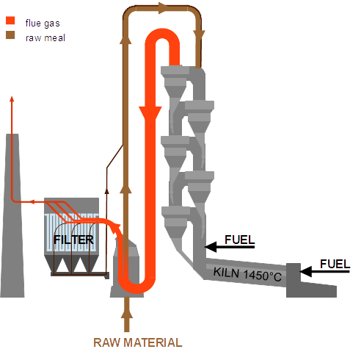
Fig. 1: Clinker plant ¹⁾

3 THE MERCURY CYCLE

One consequence of countercurrent operation is the build-up of internal cycles of inorganic materials. These are volatile at the high temperature in the kiln but condense or are adsorbed on solid surfaces at low temperature, e.g. on the input material in the raw mill (if operated in the compound mode) at a temperature of 110 °C. One such substance is mercury and its compounds. Fig. 2 depicts the flows of mercury inside the clinker process. Most of the mercury fed to the clinker process via fuels and raw material accumulates in a closed cycle inside the clinker plant. Elemental mercury and its compounds condense and/or are adsorbed in the raw mill on the large surface area of the raw meal. The raw meal is fed to the clinker burning process where the mercury and its compounds evaporate to be carried away by the flue gas to the raw mill where they then condense and/or are adsorbed on the raw meal. And so on. A small fraction of the mercury-laden raw meal reaches the kiln filter, where it is separated from the flue gas. This filter dust, too, is fed to the clinker process via the mill elevator. As consequence, mercury remains in the process and becomes more enriched over time. The mercury emission is related (might be proportional) to the mass of mercury accumulated in the clinker process. The accumulation of mercury proceeds until the output (the emission) equals the input. When the input-output equilibrium is reached, no further accumulation happens and all mercury supplied to the plant through raw materials and fuels passes through the stack to the atmosphere.
One method to control the emission of mercury to the atmosphere is splitting off a fraction of the filter dust from the recycled flow and adding it to the cement product. By steadily removing some mercury with a fraction of the filter dust, the amount of mercury mass in the process is reduced and as a consequence the emission to the atmosphere. In fact, the output with the filter dust plus the output through the stack equals the input. However, cement with high mercury content is not desired.

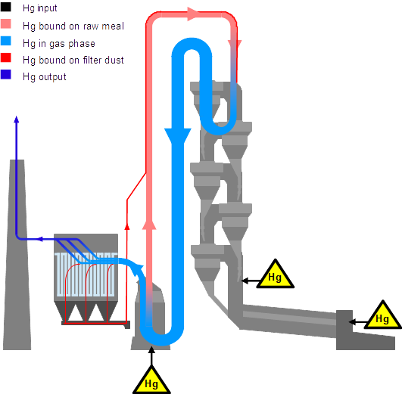
Fig. 2: Mercury cycle in the clinker process ¹⁾

4 THE “XMercury” PROCESS

The newly developed “XMercury” process relies on the fact that the filter dust collected in the kiln filter is very fine and thus has a large specific surface area upon which the mercury and its compounds are adsorbed.

In the “XMercury” process (Fig. 3) the mercury laden filter dust (with a typical load of 1 - 2 ppm Hg), is not recycled to the clinker process, but is fed to a riser-stripper, together with a hot flue gas side stream taken from cyclone No 5 of the preheater tower in order to reach a temperature of 400 °C, i.e. high enough to desorb the mercury from the dust. Then the flue gas passes a high efficiency cyclone, where the bulk of the dust is separated and recycled to cyclone No 3 of the preheater tower. The remaining (fine) dust is collected in a hot gas filter. This dust is returned to the clinker process. The particle-free, but mercury laden flue gas side stream is quenched to 100 °C with water and afterwards contacted with doped charcoal, upon which the mercury is adsorbed. In another filter the flue gas side stream is separated from the charcoal and returned to the clinker process. The laden charcoal is filled into drums for subsequent shipping. Finally, both the dust and the flue gas side stream are returned to the clinker process. Only the mercury remains on a small quantity of charcoal at a relatively high concentration.
The gas side stream which is tapped off cyclone 5 and fed to the riser-stripper amounts to less than 5000 m³/h (STP), which is less than 3 % of the flue gas flow. The operation of the “XMercury” plant does not require an increase in fuel input.
Laden charcoal may either be used as input material for the recovery of mercury, or, as is currently the case, it may be stored underground.

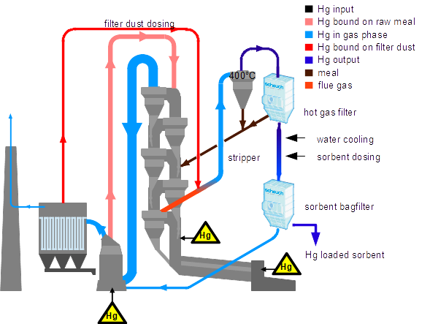
Fig. 3: “XMercury” process ¹⁾

The plant was put into operation in 2015 and has been running ever since without any serious problems. Removal ratios of 90 % and more are being achieved. Before installation of the “XMercury” plant the mercury concentration in the flue gas at the stack of the clinker plant often reached the emission limit of 50 µg/m³ (STP,10%O₂,dry, half hour average). Nowadays, measured daily averages are low, as shown in Table 1.

4.1 Performance figures of the “XMercury” process

Electricity…………………………1.5 – 2 kWh/t clinker
Additional fuel consumption is negligible
Activated carbon……………..10 – 20 g/t clinker
Personnel…………………………16 – 32 h/month

Date: October 2017 | 10 | 11 | 12* | 13** | Emission limit at  w&p Zement  (half hour mean)
Concentration  µg/m³ (STP,10%O₂,dry,  24 hour mean) | 1.31 | 1.92 | 8.17 | 14.84 | 50
* … “XMercury” plant turned off at 12:00 am for maintenance
**..”XMercury” plant not in operation

Table 1: Mercury concentration in flue gas

5 REGENERATIVE THERMAL OXIDATION (RTO)

Regenerative thermal oxidation (RTO) of organic carbon is a common process for cleaning ventilation air in many industries using organic solvents. However, since the flue gas flows in clinker kilns may be as large as 300 000 m³/h (STP), the use of RTO for oxidation of organic carbon in the flue gas of such plants is rather new.

The two main reasons for installing RTO in a clinker plant are related to::

a) Legal limits for the emission of organic carbon, and
b) Odor

The organic carbon in the flue gas of a clinker plant may have two different origins:

a1) The feed material to the plant is mostly limestone and marl. Limestone and marl contain more or less – depending on source – organic carbon. This organic carbon is stripped off the raw meal, while the raw meal passes through the preheater tower, where the temperature of the meal increases steadily. Since the temperature in the preheater tower is not high enough for combustion, the stripped off organics are not burned completely. Depending on the source of limestone and marl, the concentration of organic carbon in the flue gas may exceed 120 mg/m³. The Austrian emission limit for organic carbon originating from feed material is 120 mg/m³ (STP, 10%O₂,dry, half hour average).

a2) Those clinker plants, which burn alternative fuels (i.e. waste) face the problem that combustion is never complete and some organic carbon, which originates from the alternative fuel, is left in the flue gas. The Austrian emission limit for organic carbon, originating from the combustion of waste is 10 mg/m³ (STP, 10%O₂,dry, half hour average).
Present day measurement techniques cannot distinguish between organic carbon from feed material and organic carbon from waste. Measurement at the stack provides only information on the amount of total carbon (TOC). If, for example, the measured value is 80 mg/m³, then this may be 70 mg/m³ from feed material and 10 mg/m³ from waste, which is in compliance with the law; but it might also be the other way round, i.e. 10 mg/m³ from feed material and 70 mg/m³ from alternative fuels which is not in compliance with the law.

b) Odor: The combustion of waste in a countercurrent continuous process is not an easy task! While the flow of air is constant over time, the dosing of waste – due to its very nature – varies over time. It may happen, for example, that for a short time, not enough oxygen is present in the combustion gas and as a consequence the combustion of organic carbon will be incomplete. Some compounds of organic compounds smell and the characteristic smell of the plume disturbs neighbors.

6 FUNCTION OF AN RTO

The purpose of an RTO is to burn not only organic carbon but also CO and NH₃.
In principle an RTO consists of at least two beds of solid mass for the storage of heat (Fig. 4). A common combustion chamber is arranged on top of the two beds and connects them. A burner for
natural gas or some other clean fuel is located in the combustion chamber. Two pipelines, one for the supply of raw gas, the other for the removal of clean gas together with a number of valves, are located underneath the bed. The valves connect/disconnect the two pipelines to the beds in a cyclical manner.

During stationary operation the two beds are operated in a cyclical fashion. In cycle 1, the cold raw gas enters bed No I, which is hot. While passing through bed No I, heat is transferred from the hot solid mass to the cold gas. While flowing through bed No I, the gas is heated up. When entering the combustion chamber the temperature of the raw gas should be high enough for ignition of the organic carbon in the gas. If not, then the gas burner supplies the heat required to reach the necessary target temperature. In the w&p plant the target temperature is 850 °C. After a residence time of at least two seconds the now hot gas leaves the combustion chamber through bed No II. Since bed No II is cold, heat is transferred from the gas to the bed mass of bed No II. Thus the bed mass is heated up while the gas gets cooled. After some time (ca. 60 seconds), when bed No I has got cold and bed No II has got hot, cycle 1 is terminated and cycle 2 is started by directing the raw gas flow to bed No II. During cycle 2 the gas flow direction is the opposite of the flow direction during cycle 1. After the “live time” of cycle 2 the gas flow is switched again to start cycle 3. And so on.
From the above, it is clear that in order to change from cycle 1 to cycle 2 the gas flow must be interrupted. If this is not possible, then a third bed must be installed in order to allow for a continuous flow of the gas. The w&p Zement plant has five beds which are connected by one combustion chamber. The reasons for this are explained below.

7 THE RTO AT w&p ZEMENT

The RTO at w&p Zement in Wietersdorf, Carinthia (Austria) has five beds (fig. 5). Two beds are in the heating mode (gas flow upwards) and two beds are in cooling mode (gas flow downwards). The fifth bed is purged with clean gas in order to avoid the slippage of raw gas to the clean gas side during switching. Purging is necessary, since otherwise, when the gas flow is reversed during switching, raw gas would be pushed back into the clean gas pipeline.

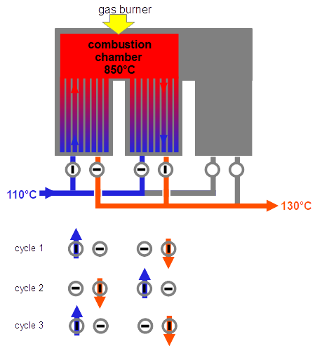
Fig. 4 RTO principle

In order to ensure complete combustion, a minimum oxygen content in the flue gas at the entry to the RTO is obligatory. In the w&p-plant this is 4 % vol. O₂. If the oxygen content is too low, then a butterfly valve in the raw gas duct opens to suck in ambient air.
In an ideal operation, no additional heating with gas should be necessary. However, heat transfer from the solid mass to the gas and vice versa requires a temperature difference between gas and solid mass. This has the consequence, that the clean gas exiting the RTO is always some 20 - 30 °C hotter than the entering raw gas. In order to compensate for this, and for heat loss to the environment, heat must be supplied to the system by, for example, a gas burner. However heat is not only supplied via the gas burner but also via the combustion of the organic carbon and of CO. A clinker plant with a calciner like that used by w&p has the freedom to run the combustion in the combustion chamber of the calciner in such a way, that enough organic carbon and CO are left as fuels in the raw gas for the self-sufficient operation of the RTO. Self-sufficient operation is possible with a CO concentration of 5 000 – 7500 mg/m³ (STP,10%O₂,dry) in the raw flue gas.

In Austria there are at present three clinker kilns equipped with RTO. The objective is to remove TOC and odors from the flue gas. The RTO plant under consideration started operating on October 1st 2017. So far, the results have been very satisfactory. Preliminary results show, that the emission of CO and Corg are as low, as the measurement uncertainty. Final data will be presented at the symposium.

Through the installation of RTO and “XMercury” the clinker plant of w&p has become a forerunner in environmentally benign clinker production.

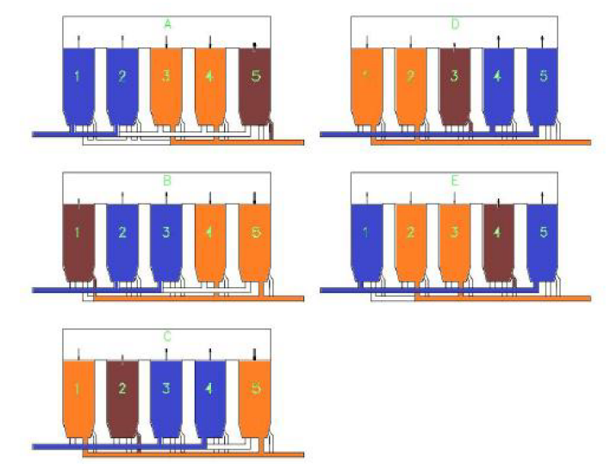
Fig. 5: RTO at w&p Zement Wietersdorf ¹⁾

7.1 Performance figures of w&p Zement RTO

Electricity consumption: 8 – 10 kwh/t clinker
No extra personnel
Gas consumption by burners: not yet estimated

¹⁾ Figures taken (in part) from Scheuch sales pamphlets (www.scheuch.com)

