To investigate the effects of talc on floor tiles glaze as opacifier
Murtaza Khan*, Zahid Ur Rehman**, Saad Ullah Khan***
* Department of Chemical Engineering UET Peshawar
** Department of Mining Engineering, UET Peshawar
*** Department of Chemical and Material Science Engineering GIK
Email: murtaza_forte@yahoo.com

Abstract
Whiteness and opacity of floor tile glazes are usually developed by changing composition of the raw materials. Traditionally, in ceramic tiles industry zirconium silicate (ZrSiO₄) is widely used as opacifier. However, the high cost of zirconium limits its uses. In this study, alternative glazes with suitable whiteness and opacity were investigated using talc (Mg₃Si₄O₁₀(OH)₂) as opacifying agent and gradually eliminating ZrSiO₄ content in the glazes. Six samples of glazes (including standard sample) were prepared, sprayed and fired in single fired floor tile roller kiln under industrial conditions. The microstructure and mineralogical composition of glazes were characterized by using Scanning Electron Microscope (SEM) and Energy Dispersive X-Ray (Spectroscopy) EDX. Various physical tests were also done on all samples of glazes in order to investigate the effects of addition of talc on the floor tile glaze. The results of density of the sample glazes revealed that the density of the samples decreased by the addition of talc. The strength of the glazed and fired floor tiles was also tested which showed that the strength of glazed and fired floor tiles sample was not affected significantly, which is directly related to the ceramic tiles body composition and firing temperature of the kiln. The whiteness and opacity of glazes was measured by CIELAB color space. This research work revealed that the glazes containing talc were found more economic and better in fluxing properties, opacity and whiteness which may be attributed to crystalline structure of the talc.
Keywords: talc; opacifier; floor tiles; glaze.

- Introduction
To provide opacity to glaze various opacifiers just like Titanium dioxide, TiO₂, Tin oxide and Zirconium Silicate are usually used. The opacity is achieved by scattering and reflecting the incident beam of light to glazed surface of tile. Therefore, opacity is directly related to the index of reflection of opacifying agent present in that ceramic glaze matrix. Among the various opacifiers used in floor tile glaze, the zirconium silicate is predominant [1]. But when it used in huge quantity it affects the quality of the product. However, the high cost of zirconium limits it uses in various ceramic glazes [2]. Commercially ZrSiO₄ has is substituting by different oxides but it has been found that those opacifying agents affect the glossiness of glaze. For example the use of TiO₂ reduce the brightness of glaze with increasing the firing temp [1].
In this research work talc (Mg₃Si₄O₁₀ (OH)₂) is used as opacifier in ceramic floor tile glaze and the ZrSiO₄ is eliminated by talc gradually. The use of talc (Mg₃Si₄O₁₀(OH)₂) in the ceramics is not new however , it has been using as a fluxing agent so far [3,4]. The aim of this study is to investigate the possible effects of talc as ceramic glaze opacifier on floor tile and to reduce the cost of glaze by substituting economic opacifier.
2. Materials and Method
2.1. Preparation of glaze
Five sample glazes along with reference glaze sample were prepared according to their respective compositions in weight % as shown in Table 1.

Table 1 Composition of various glaze samples (weight %)
Raw materials G.ref G.1 G.2 G.3 G.4 G.5___________________
Frit 37 37 37 37 37 37
Potash Feldspar 25 25 25 25 25 25
Quartz 17 17 17 17 17 17
Zirconium Silicate 15 12 09 06 03 0
Talc 0 03 06 09 12 15
China Clay 06 06 06 06 06 06
______________________________________________________________________________
The raw materials used for the samples preparation were potash feldspar, China clay, commercial frit, quartz, talc, and Zirconium silicate. Each sample was milled in the laboratory jar mill by wet grinding process. 40 ml of water per 100 gram of each recipe was added to the jar mill. In order to improve the rheological properties of sample glazes, 0.07 gram of Carboxyl methyl cellulose (CMC) and 0.2 gram of Sodium Tripoly-phosphate (STPP), were added per 100 gram of each sample. The residue of each sample glaze was kept 1% using 63 microns sieve. The density of each sample was measured by pycnometer and maintained in the range of 1800-1820 g/liter.
2.2. Method
After preparing the sample glazes, each glaze was sprayed on green floor tile with the help of spray gun and dried in tray dryer at 110 C for 1 hr and then each glazed floor tile was subjected to roller kiln under industrial conditions for 50 minutes, having peak temperature 1120-1150◦C. After 50 minutes all sample floor tiles were collected at the exit of the kiln. Schematic of this process is shown in Figure 1.
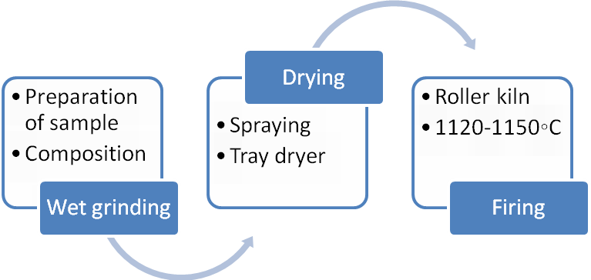
Figure 1 Schematic of process for producing glazed floor tiles
The following tests were carried out to determine the effect of adding talc as opacifier in the glaze for floor tiles:
Density of all sample glazes including reference sample was measured with the help of pycnometer.
The fluxing time (viscosity) for sample glazes was measured with a Ford-Cup viscometer with a hole of 3mm diameter and volume 100 ml, and kept in range 30 sec to 35 sec. To determine the susceptibility of ceramic glazed floor tiles, all the six samples were exposed to acidic and basic mediums. The sample tiles were tested in 5% HCL and 30 g/L KOH.
In order to determine the effect of talc as opacifier, the opacity of all samples floor tiles were found by using a CM-700d Spectrophotometer (Konica Minolta) in the CIE L*a*b* system, where L, a and b represent degree of whiteness, greenness and yellowish respectively.
The surface morphology of the sample glazes was investigated using Scanning Electron Microscope (SEM) and EDX.

3. Results and discussion
In this study, the physical properties of ceramic floor tile samples prepared by adding various amounts of talc to standard glaze sample were investigated in relation to its opacity and whiteness. Results are presented and discussed in this section. The results of density test of each glaze are presented in Table 2 and Figure 2.
Table 2 Properties of glazed floor tiles
Glaze sample | Density (gm/L) | Fluxing time (sec) | Flexural strength (kg/cm2)
G.ref | 18 22 | 32 | 334
G1 | 1817 | 31 | 327
G2 | 18 16 | 32 | 337
G3 | 1813 | 33 | 340
G4 | 1811 | 33 | 331
G5 | 1808 | 36 | 337

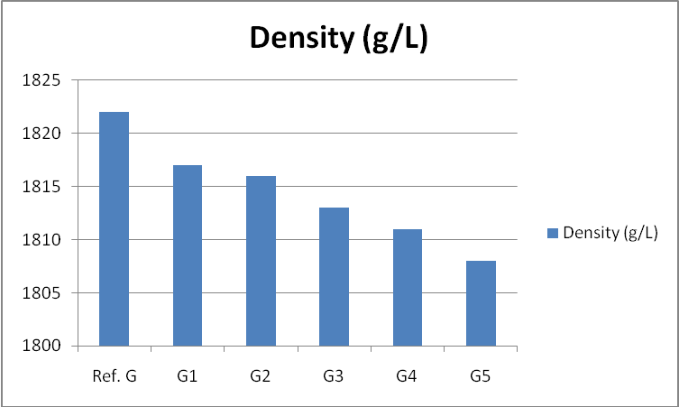
Figure 2 Density of glazed floor tiles samples
It may be observed from Figure 2 that as the percentage of talc increases the density also decreases. The density of the sample glazes decreased gradually by the addition of talc and reducing the percentage of Zirconium silicate. This change / decrease in density is the function of bulk density of talc which is less than ZrSiO₄ bulk density. The results of fluxing time are shown in Table 2 and Figure 3.
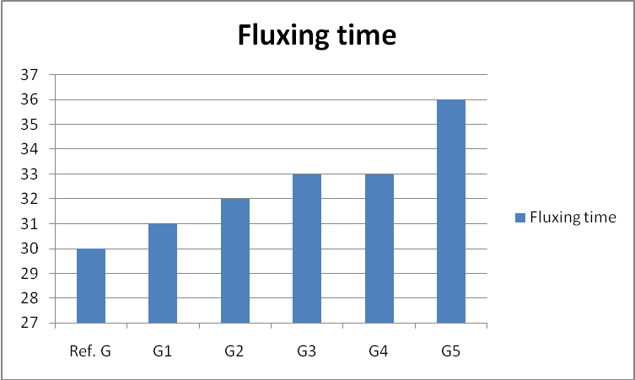
Figure 3 Fluxing time of glazed floor tile samples
The results indicate that the addition of talc and reduction of zirconium silicate percentage, in the glaze recipes increase the fluxing time. This increase in viscosity is due to the specific rheological properties of talc [5].
Flexural strength of glazed floor tiles is shown in Figure 4.
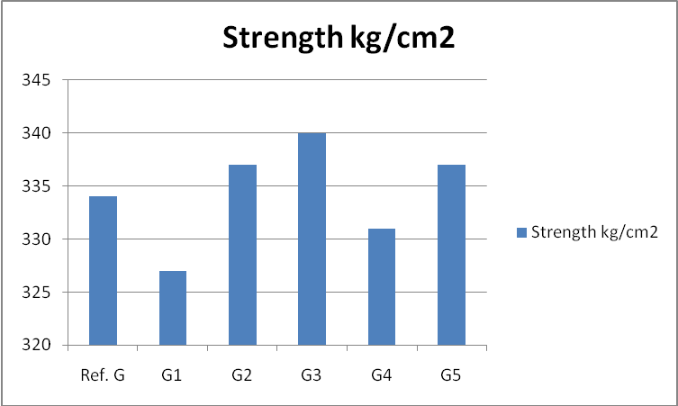
Figure 4 Flexural strength (kg/cm2) of glazed floor tiles samples
From the results of strength test, it can be clearly seen that values of strength of all fired floor tiles samples were found close to each other. It was also found that strength of fired samples was not affected significantly. The strength of a tile is the function of composition of ceramic bodies and the firing temperature of the kiln [5]. Since the values are in the range of 334- 340 kg/cm²
This is also consistent with standard TS-EN 176 [6]. The color index of glazed floor tiles samples is shown in Table 3:
Glazed Floor tile Samples | Ref. G | G1 | G2 | G3 | G4 | G5
L* | 90 | 90.3 | 90.1 | 90.4 | 91.6 | 92.8
a* | 1.2 | 1.4 | 1.3 | 1.2 | 1.6 | 1.4
b* | 6.9 | 6.9 | 6.4 | 6.4 | 6.6 | 6.5
Table 3 Color index of glazed floor tiles samples
It may be observed from Table 3 that as the value of talc increases the opacity also increases. L* value of G.5 is high as compare to G.ref where L* represents degree of whiteness, a* degree of greenness and b* yellowish.
The SEM micrograph and EDX elemental analysis is shown in Figure 5:
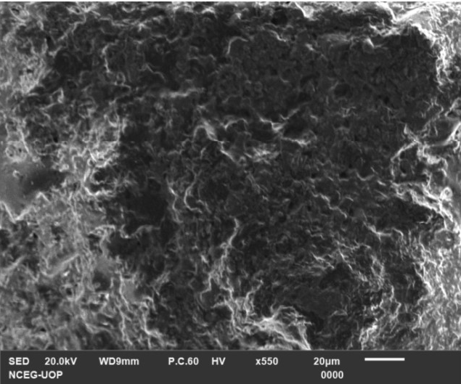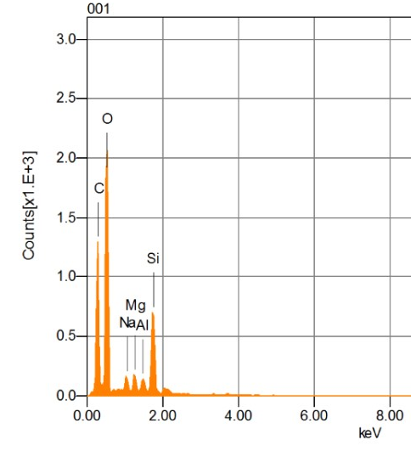
- b)
Figure 5 SEM and EDX analysis of G.ref sample of glazed floor tile
Similarly, the SEM micrograph and EDX elemental analysis of glazed floor tile in which Zirconium silicate has been completely substituted with 15% talc is shown in Figure 6.
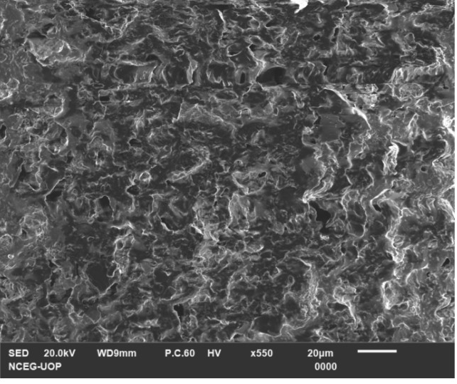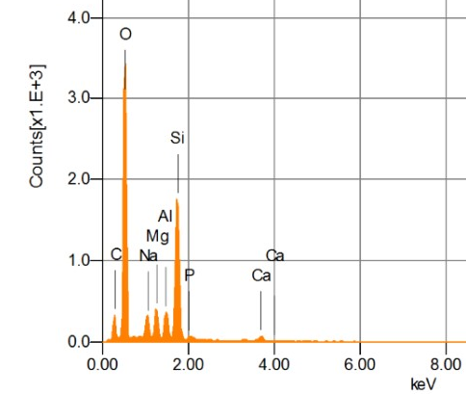
- (b)
Figure 6 SEM and EDX analysis of G.5 sample of glazed floor tile
The SEM microscopic observations were taken at cross-sections of the ﬁred glazes without polishing. A comparison of Figure 5 and Figure 6 indicates that the size of crystals in glazed floor tiles without talc is larger than the glazed floor tiles with 15% talc. This may be attributed to lower viscosity indicated by lower fluxing time. Similarly it is also observed from Figure 6 (a) that the crystals of talc are distributed uniformly. These results are in conformity with the observations of Gajek et al. [7].
4. Conclusions
In this work talc was substituted in place of Zirconium silicate for glazing of floor tiles. Results indicate that increasing the amount of talc by reducing Zirconium silicate decrease the density, fluxing time increased indicating increase in viscosity. Flexural strength varied but remained in acceptable limits as strength depends on composition of ceramic body. The color index indicated that same degree of whiteness can be achieved by replacing Zirconium silicate with talc.

References
[1] Magagnin, D., dos Santos, C.M.F., Wanderlind, A., Jiusti, J. and De Noni, A., 2014. Effect of kaolinite, illite and talc on the processing properties and mullite content of porcelain stoneware tiles. Materials Science and Engineering: A, 618, pp.533-539.
[2] Teixeira, S. and Bernardin, A.M., 2009. Development of TiO₂ white glazes for ceramic tiles. Dyes and Pigments, 80(3), pp.292-296.
[3] Chandra, N., Agnihotri, N. and Bhasin, S.K., 2004. Sintering characteristics of talc in the presence of phosphatic and alkali carbonate sintering activators. Ceramics international, 30(5), pp.643-652.
[4] Da Silva, R.C., Pianaro, S.A. and Tebcherani, S.M., 2012. Preparation and characterization of glazes from combinations of different industrial wastes. Ceramics International, 38(4), pp.2725-2731.

[5] CA Wah, Ly Choong, GS Neon., 2000. Effects of titanate coupling agent on rheological behavior, dispersion characteristics and mechanical properties of talc filled polypropylene European Polymer Journal,24(8) ,pp571-665

[6] Yamık, İ.Bentli, C.Karagüzel, M.Çınar & B.Cengiz ,The Application of Colemanite Addition to Floor Tile Glazes University of Dumlupinar, Department of Mining Engineering, Kütahya, Turkey 17th International Mining Congress and Exhibition of Turkey- MCET2001, ©2001, fSBN 975-395-4Î7-4
[7] Gajek, M., Partyka, J., Rapacz-Kmita, A. and Gasek, K., 2017. Development of anorthite based white porcelain glaze without ZrSiO₄ content. Ceramics International, 43(2), pp.1703-1709.

