Comparative study on the effect of acid gas cleaning by MDEA vs.(MDEA + Piperazine) as a solvent using Aspen Hysys.

Naveed Islam¹, Muddasar Habib² and Murtaza khan³

¹ Department of Chemical Engineering, University of Engineering & Technology Peshawar, Pakistan.

² Department of Chemical Engineering, University of Engineering & Technology Peshawar, Pakistan.
³Department of Chemical Engineering, University of Engineering & Technology Peshawar, Pakistan.

Abstract
Natural gas is considered as a clean fuel gas in comparison with other fossil fuels. The Natural gas found in the reservoirs is not purely clean and must be treated.
In this research a process simulation model was developed on the basis of the real plant data obtained from the gas cleaning facility located at jhand, Punjab [Pakistan] for the removal of acid gases such as H₂S and CO₂ using absorption process in Aspen HYSY simulation software v9.0 and was validated. Piperazine (1%) by mass fraction when blended with MDEA solution increases the rate of absorption of CO₂ from natural gas. Two different process simulation models were developed for acid gas removal using Aspen HYSYS for two different solvents i-e MDEA and Piperazine activated MDEA solution. The Aspen HYSYS process simulation software v9.0 worked great with the actual plant data and the results were in agreement with each other within +-17% error. From the comparison of two simulation models it was concluded that the recirculation rate of the solvent was decreased from 359 USGPM to 216.7 USGPM and have higher efficiency of 8% especially for CO₂ removal by using Piperazine blended with MDEA solution. The energy requirements of stripper were also decreased by 683 hp.
Keywords: Acid gas, Absorption, Aspen Hysys, MDEA, Piperazine, Stripping, Vapor liquid equilibrium, Distillation
- Introduction
Natural gas is also known as “clean burning fuel” because it produces less undesirable by-products per unit energy than coal or petroleum. In comparison to all fossil fuels, combustion of natural gas emits CO₂, but at about half the rate of coal per kilowatt hour of electricity generated. It produces greater energy and is more efficient. On average, a typical coal-burning power plant in 2013 was about 33% efficient in converting heat energy into electrical power. A gas-fired plant was about 42% efficient. In natural gas combined cycle power plants the waste heat from a natural gas turbine is used to power a steam turbine—generation may be as much as 60% efficient ^{[1]}.
Apart from being beneficial, it also contains impurities like H₂S, CO₂ and other sulfur compounds. The world most part of natural gas contains acid gas impurities like H₂S and CO₂ which must be removed in order to achieve pipeline standard requirement for injecting into the pipelines (Pakistani standard). The acid gases must be removed because of achieving transport requirements and sales gas specifications. The H₂S must be removed because of its toxic nature. Aqueous alkanol-amine solutions are the most widely and commercially used solvents in industry to absorb acid gases from natural gas. This research addresses the use of alkanol-amine solutions for acid gas cleaning from natural gas ^{[2]}.
Gases containing sulfur compound impurities are called sour gases. A natural gas containing hydrogen sulfide content of more than 5.7 milligrams of H₂S per cubic meter of natural gas (4 ppm by volume) are called sour gas. The process used for removal of acid gases like H₂S and CO₂ are called sweetening process because they result in products that no longer have acid gases.
Rapid economic growth has added much to today's ever increasing demand for energy. Due to which the use of fuel is increasing, particularly the conventional fossil fuels (i.e. coal, oil and natural gas) that have become key energy sources since the industrial revolution. However, the abundant use of fossil fuel has become a cause of concern due to their harmful effects on the environment), a major anthropogenic greenhouse gas (GHG). According to the emission database for Global Atmospheric Research ^{[3]}, global emission of CO₂ particularly related to the emission of carbon dioxide (CO₂ was 33.4 billion tons in 2011, which is 48% more than that of two decades ago.
Initially, the monoethanolamine (MEA) was a very popular solvent for the acid gas cleaning process. This was then substituted for the diethanolamine (DEA) due to the best in-practice obtained results. However, in the last times the methyldiethanolamine (MDEA) has gained more popularity. Mixtures of amines are also used in the industry ^{[4].}
DEA is considered the most common absorbent between primary and secondary ammines. DEA is less expensive, can be easily installed and operate than MEA ^{[5]}.
As MDEA is more expensive than MEA and has lower rate of reaction with CO₂ compared to primary and secondary amines, due to its unique nature, the following advantages make it the most widely used amine in natural gas treatment industry. Selective absorption of H₂S from its mixture with CO₂, low heat of reaction of acid gases with MDEA results in significantly lower regeneration energy compared to MEA, significantly lower vapor pressure which reduces amine loss by evaporation, higher absorption capacity, very low corrosion rate, high thermal and chemical stability, lower corrosion rate and lower vapor pressure allows the use of higher concentration of MDEA in the absorber column that results in lower circulation rate and consequently smaller plant size and lower plant cost, the lower miscibility of MDEA with hydrocarbons result in negligible loss of the hydrocarbons. Due to the mentioned advantages when only removal of H₂S is desirable, MDEA is solely used as the absorbent. For simultaneous removal of H₂S and CO₂ certain additives are used in MDEA based solution.
It is worth notable that since reaction rate of CO₂ with MDEA is slower, additives such as Piperazine having faster reaction rate with CO₂ are used to enhance the rate of reaction between CO₂ and MDEA. By adding the faster reacting amine in the appropriate required concentration to MDEA, the desired CO₂ removal can be achieved without losing all the advantages that MDEA offers over other amines ^{[5]}.
The Piperazine has faster reaction kinetics with the CO₂ but is limited by the capacity and MDEA having larger capacity for CO₂ absorption but is limited by the slower reaction kinetics with CO₂. Hence blending of MDEA and PZ has the potential to combine high CO₂ absorption capacity of MDEA and favorable kinetics of PZ for CO₂ ^{[6]}.
- Process Description
The most widely and industrially used process for the acid gas removal is an absorption process. This is a process in which the feed gas enters into the absorber/contact tower. The tower may contain different types of trays i-e sieves, valves or bubble cap trays. The Lean ammine solution is added at the top of the absorption column from where it is sprayed from above. Gas being lighter is entered at the bottom of the absorber. The feed gas and lean ammine solution goes counter currently through the trays and mass transfer from the feed gas i-e acid gas into the lean ammine occurs. The lean ammine is now enriched with the acid gas and so called as rich ammine. The lean ammine is being free of acid gas that’s why it is called as lean ammine. The treated gas is now free of acid gas and is called as sweet gas which can then be further processed.
The rich ammine is then routed through a pressure reducing valve and is then passed through a Separator where lighter hydrocarbons if any are separated. The rich ammine stream is then passed through heat exchanger where it gets pre-heated and the lean ammine coming from the regenerator gets cooled.
The rich ammine is then fed into the regenerator column at the top and is heated at a temperature of 250°F. The acid gases having lower boiling points than MDEA are obtained at the top and the lean ammine after passing through the heat exchanger is fed into the make-up tank where fresh MDEA and water is added to the lean ammine stream. To increase the pressure and decrease the temperature of the lean ammine stream it is pumped and cooled. The lean ammine stream is then recycled into the absorption tower as shown in figure 1.

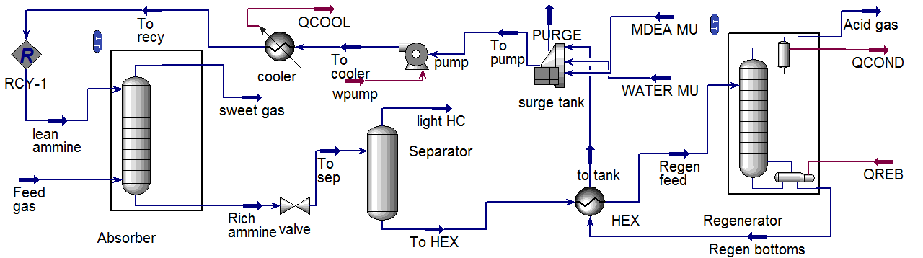
Figure 1: Process flow diagram of acid gas cleaning by MDEA through Aspen Hysys v9.0.
- Steady state simulation through Aspen Hysys
Aspen Hysys is an important tool used for the simulation of different process including acid gas sweetening plant. The process simulation of acid gas removal by absorption was simulated through Aspen Hysys by taking the field data from one of the field of OGDCL, Dakhni, Punjab Pakistan. The data was simulated through Aspen Hysys and then the efficiency removals of acid gas were validated with the plant data.
The feed gas conditions and composition for ammine solvent is shown in Table 1, Table 2 and Table 3 respectively. In the case of Aspen Hysys, the ﬂuid package selected was acid gas -chemical solvent. The acid Gas property package was developed with the Peng-Robinson equation-of-state for vapor phase and the electrolyte non-random two-liquid (eNRTL) activity coefﬁcient model for electrolyte thermodynamics ^{[7]}. The property package contains the eNRTL model parameters and other transport property model parameters identiﬁed from regression of extensive thermodynamic and physical property data for aqueous amine solutions ^{[8].}

Table 1: Conditions of the feed gas
Feed gas
Temperature 110°F
Pressure 1300psia
Molar Flow 25.05 MMSCFD

Table 2: Feed gas composition data
S.no | Components | Mole fractions
1  2  3  4  5  6  7  8  9  10  11 | C₁  C₂  C₃  i-C₄  N-C₄  i-C₅  N-C₅  C₆+  N₂  CO₂  H₂S | 0.838596  0.034821  0.012673  0.003027  0.003752  0.001334  0.001962  0.001204  0.003782  0.036349  0.062500

Table 3: Conditions and composition of feed solvent (MDEA to absorber)
Temperature  Pressure  Mass fraction of MDEA  Mass fraction of Water  Std ideal liquid vol flow  Mass fraction of CO₂  Mass fraction of H₂S | 110°F  1300psia  0.4500  0.549209  359.8USGPM  0.0000  0.0000

After creating the Simulation environment, the process simulation model is built in Aspen Hysys as shown in figure 1. The temperature of the absorption column varies along the tray position from 110°F to 137.5°F as shown in figure 2.

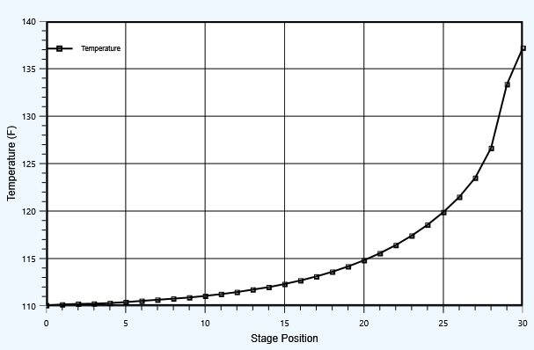
Figure 2: Temperature variance with stage position from the top.
The pressure remains constant along the stage position in an absorption tower. The H₂S and CO₂ composition varies along the stage position in an absorber as shown in figure 3 where the decrease in the composition of acid gases when the feed gas is going from bottom to top of the absorber is because of absorption of acid gas by the lean ammine (MDEA) stream. Unlike H₂S the composition of CO₂ does not goes down but it decreases very slowly showing that the absorption of H₂S in MDEA is very fast as compare to CO₂ and the CO₂ composition reaches to approximately 1.722e-004 mole fraction at stage number 1 from 1.519e-002 mole fraction at stage number 31, as shown in figure 3.

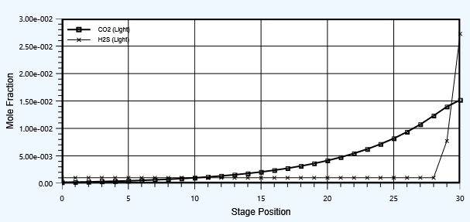
Figure 3: CO₂ and H₂S composition vs tray position from the top
The viscosity varies along the tray position in an absorber in such a way that it decreases from 3.665 CP to 2.265 CP on the basis of mass and a phase of light liquid, as shown in figure 4 and hence increase in the mass transfer rate occurs down the absorption column because of less resistance to mass transfer from gaseous phase to liquid phase.

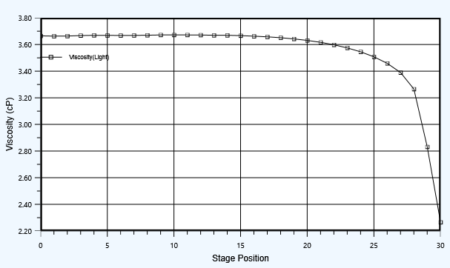
Figure 4: Viscosity variation along the tray position from top in an absorption tower
The basic principle of removing acid gases from a rich ammine stream is by subjecting it to low pressure and high temperature so that the low boiling liquids leave the regenerator at the top and the lean ammine stream at the bottom. The temperature of the regenerator increases directly with the increasing pressure as can be seen in figure 5. The temperature is increased by the reboiler of the regenerator. So it can also be seen that the temperature increases also with increased pressure. The pressure in a regenerator is therefore kept lower initially so as not to increase the temperature to avoid the evaporation of ammine stream with acid gases.
Acid gases like H₂S and CO₂ are removed from the ammine stream in a stripper. The rich ammine stream having acid gases are in higher concentration initially when enters the regenerator, it goes down through a number of trays and is get heated by the reboiler. The lighter boiling liquids i-e CO₂ and H₂S are removed from the ammine stream as it goes down the column from tray 1 to tray 31 and their mole fraction decreases down the column as can be seen in figure 6.

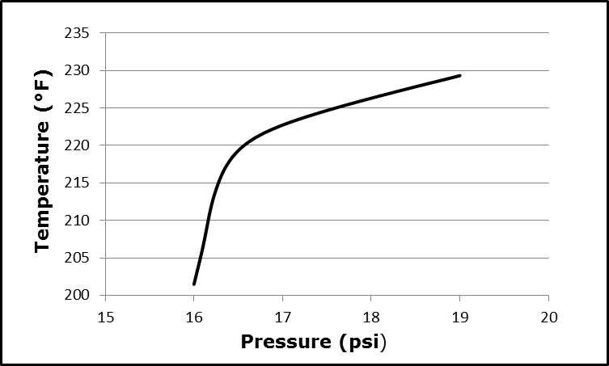
Figure 5: Temperature vs pressure in a regenerator

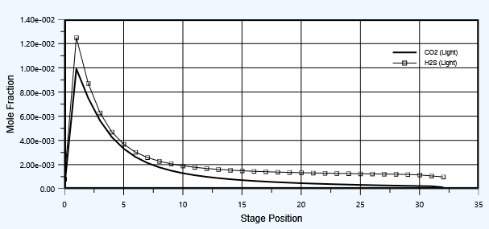
Figure 6: Composition of CO₂ and H₂S vs. Tray position from top

Acid gas composition like CO₂ tends to decrease by increasing pressure. It is because the temperature also increases with the increase of pressure in the stripper column. And the acid gases then evaporates from the lean ammine (MDEA) stream as can be seen in the figure 7 and its composition decreases. The H₂O composition increases with the increase in the pressure.

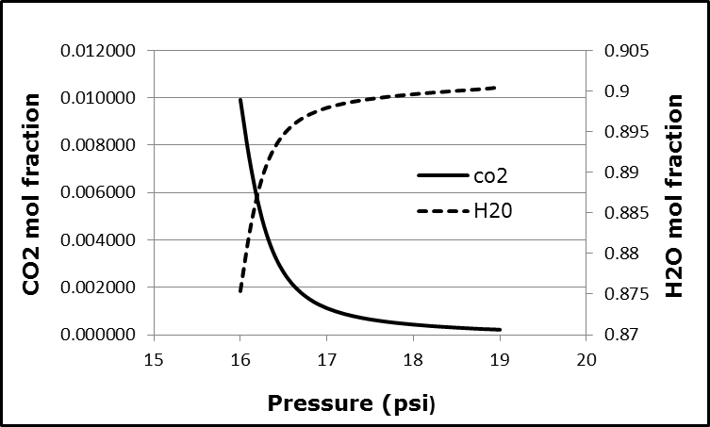
Figure 7: Composition of CO₂ and H₂O vs Pressure of a stripper
The CO₂ concentration in the sweet gas depends on the MDEA concentration and its flow rate. The MDEA concentration of the lean ammine stream was varied from 0.25 at a MDEA stream flow rate of 284.3 USGPM at which the CO₂ mole fraction was 0.0014. Similarly by increasing the MDEA mass fraction to 0.55, the CO₂ mole fraction in the sweet gas decreases to 0.0004 but at the same time the MDEA flow rate also increases to 415.54 USGPM as shown in figure 8. So an optimum value for MDEA mass fraction which is equal to 0.45 and an optimum flow rate was selected which is 359.8 USGPM.

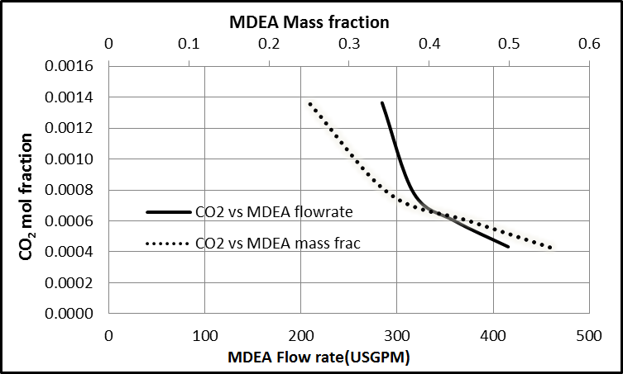
Figure 8: Effect of MDEA concentration and flow rate on CO₂ in the sweet gas
- Simulation model validation
The model was simulated for 31 numbers of trays of an absorber and having top and bottom pressure the same as 1300 psia. The lean ammine stream is at a temperature of 110°F and the feed gas at a temperature of 100°F. The model was simulated through Aspen HYSYS that removed the acid gases from the feed gas and the lean ammine absorbed the acid gases and becomes rich. The sweet gas was then collected from the top. The sweet gas composition data was then compared with the real plant data by drawing a graph as shown in Figure 9.

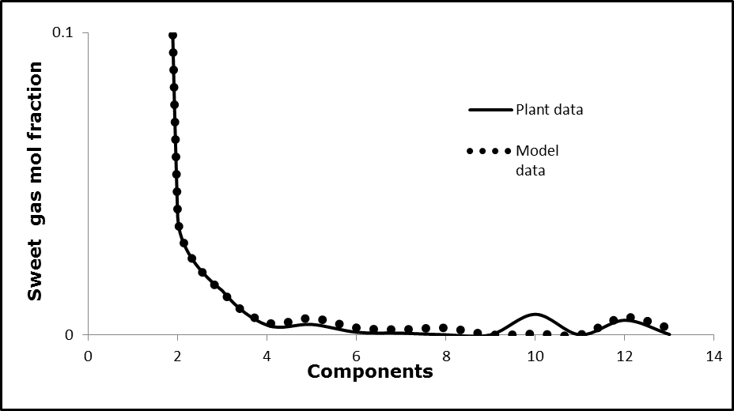
Figure 9: Sweet gas mole fraction vs. different components of the sweet gas of the real plant data and simulation data.

By having a look into the figure 9, both the plant and the Aspen HYSYS simulation data matches exactly for within +-17% for acid gases such as CO₂ and H₂S. It means that Aspen Hysys gives a good approximation for the real plant process calculations. The components at different serial numbers are taken from table 2 as can be seen that at serial no 10 and 11 are CO₂ and H₂S respectively.
- Sensitivity Analysis:
  - Sensitivity Analysis of Piperazine vs CO₂ level in sweet gas:
By varying Piperazine concentration in the PZ-MDEA ammine stream, the CO₂ concentration is affected. By increasing Pz concentration in the lean ammine stream when MDEA concentration is kept constant at a concentration of 42% by mass, the CO₂ level in the sweet gas goes on decreasing as shown in figure 10. From the following figure, it can be seen that the CO₂ level decreases sharply upto 1% Pz concentration by mass and then slowly by increasing Pz concentration.
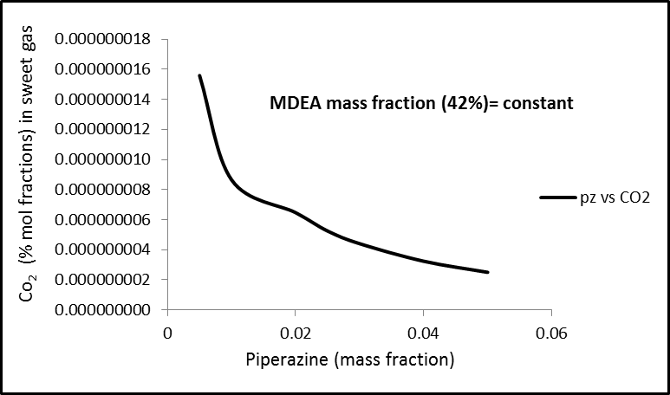
Figure 10: Effect of varying PZ-MDEA flow rate vs CO₂ level in the sweet gas

  - Sensitivity Analysis of Piperazine vs H₂S level in sweet gas:
By increasing PZ concentration in the PZ-MDEA ammine stream, the H₂S goes on decreasing sharply upto 1% by mass as can be seen in the following figure. So an optimum concentration (1% Pz by mass) to decrease the acid gas in the sweet gas of the lean ammine is a better option.

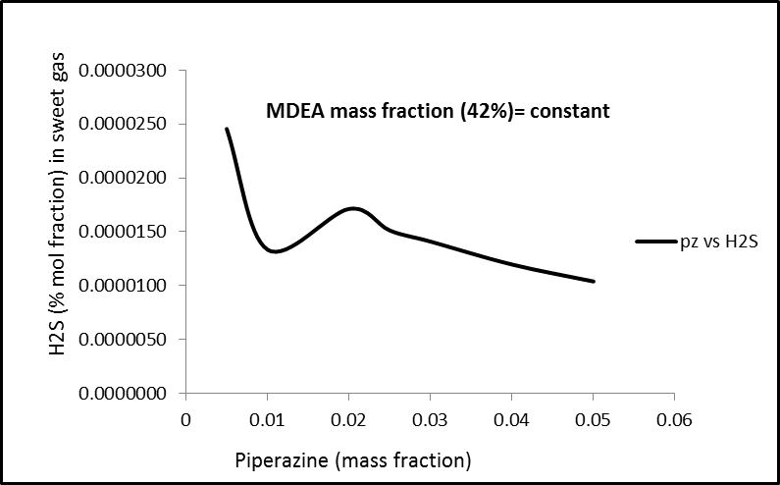
Figure 11: Effect of varying PZ-MDEA flow rate vs H₂S level in the sweet gas
- Results and Discussion
  - Effect of number of trays on the removal efficiency of acid gases:

For the same feed conditions discussed in Table 1 and the same feed gas composition and MDEA as a solvent for the removal of acid gases. Another model was simulated in which there was only a minor change in the design calculation of absorption tower i-e decreasing the number of trays from 31 to 20. But when the number of trays were decreased from 31 to 20 and the model was simulated successfully, the removal efficiency of acid gas especially CO₂ decrease to 92.47% from 99.12%. It means that decreasing the number of trays effects the CO₂ concentration in the sweet gas.

6.2 Effects of Piperazine blends with MDEA on
Acid gas removal:

For the same feed gas conditions and the same feed gas composition given in Table 1. The solvent used was Piperazine 1% blends with MDEA 42% (mass fraction). The process simulation model was simulated and converged successfully. The numbers of trays were reduced from 31 to 20. The acid gas composition in the sweet gas stream decreases and the removal of acid gas efficiency increases to 100% for CO₂. This was all because of using 1% by mass fraction of Piperazine blended with MDEA.

6.3 Comparison of the model based on MDEA and
Piperazine blends with MDEA:

Two process simulation models were developed through Aspen HYSYS v9.0 for the conditions given in Table 1 and feed gas composition in Table 2. The first model based on MDEA as a solvent and another model based on Piperazine blends with MDEA as a solvent. For the number of trays used in both models equal to 20, both the models were compared and there was an increase an efficiency of about 8.0% just by using a 1% Piperazine by mass fraction mixed with 42% methyl, Di-ethanol ammine.
The two models were also compared for acid gas removal and the solvent recirculation rate as shown in figure 10.

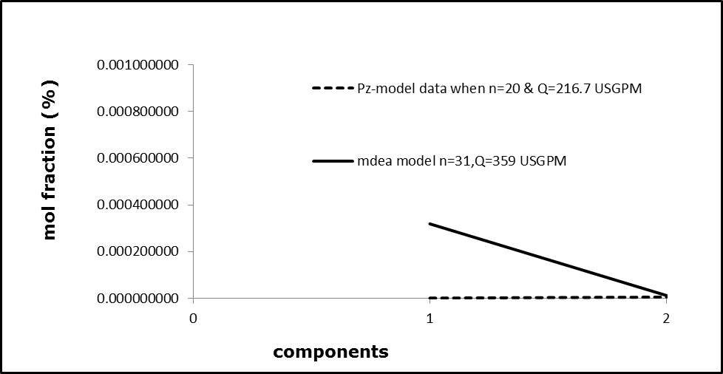
Figure 12: mole fraction vs components of acid gas of different simulation models

The components at serial no 1 and 2 are CO₂ and H₂S respectively. The simulation model data based on Pz-mdea solution as a solvent completely removes acid gas and with a solvent recirculation rate of 216.7 USGPM as shown in figure 10.

  - Comparison of the Energy requirements of the
stripper for both the models:

The heat flow and power requirements for simulation model based on MDEA as a solvent was 14.61 MMBTU/hr and 5741 hp. Similarly the heat flow and power requirements for simulation model based on PZ-MDEA as a solvent was 12.87 MMBTU/hr and 5058 hp.
The heat flow for PZ-MDEA as a solvent decreases by 1.74 MMBTU/hr and and power requirement by 683hp.
Conclusions
- Due to the blending of PZ with MDEA, the recirculation rate of the solvent decreased from 359.8 USGPM to 216.7 USGPM.
- By blending of 1% Pz (mass fraction) the efficiency of CO₂ removal increased from 92% to 100%, when the numbers of tray were decreased from 31 to 20.
- The power requirement of the stripper decreased by 683 hp due to the blending of Pz with MDEA used as a solvent.
Acknowledgements
First and foremost, I would like to thank God, the Almighty, for nothing is possible without His will. (My success (in my task) can only come from Allah (God). In Him I trust, and onto Him I look). [Quran 11:88].

First of all, I would like to thank my beloved parents for their continuous support and unconditional love throughout my life.
After that, I would like to pay my profound gratitude to my supervisor Dr. Muddasar Habib, Associate Professor, Department of Chemical Engineering, University of Engineering and Technology Peshawar, for his continuous support and guidance throughout this work till completion. I am really thankful to him for his motivation all along this journey. A special thanks for his countless hours of reflecting, reading, encouraging and most of all patience throughout the entire process.
I also pay my special gratitude to Dr. Saeed Gul,
Dr. Muhammad younis, and Dr. Muhammad Imran Ahmad, who were there to help me all the time.
I am also very thankful to my colleagues especially to Engr. Saad Ullah Khan for his countless help and guidance.

REFERENCES
- Available online at “http://needtoknow.nas.edu/energy/energy-sources/fossil-fuels/natural-gas/”, accessed on 5/17/17, 10:14PST.
- N. Sadegh, E. H. Stenby, and K. Thomson, “Acid gas removal from natural gas with alkanolamines: A Modeling and Experimental study”,Phd thesis, DTU chemical Engineering, Technical university of Denmark, Kgs. Lyngby, Denmark, 2013.
- “Emission database for global atmospheric research EDGAR”, European Commission”, available online at <http://edgar.jrc.ec.europa.eu/overview.php?v> ¼CO₂ts1990-2011, accessed on 03/03/2017 at 11:00 PST.
- Al-Lagtah, N.M.A., Al-Habsi, S., Onaizi, S.A., “Optimization and performance improvement of Lekhwair natural gas sweetening plant using Aspen HYSYS”, J. Nat. Gas Sci. 2015, Eng. 26, 367-381.
- Abbas, T., Ghauri, Z., Rashid, M., “Dynamic simulation of sweetening process of natural gas”. Can. J. Chem. Eng.Technol. vol. 2 (No. 9), 2011.
- N. Sadegh, E. H. Stenby, and K. Thomson, “Acid gas removal from natural gas with alkanolamines: A Modeling and Experimental study”, Ph.D. thesis, DTU chemical Engineering, Technical university of Denmark, Kgs. Lyngby, Denmark, 2013.
- Peter Thompson Frailie, “Modeling of Carbon Dioxide Absorption/Stripping by Aqueous Methyldiethanolamine/Piperazine”, The University of Texas at Austin, B.S. CH.E, vol 2, 2014, pp.32-33, 2014.
- Y. Song, C.C, Chen, “Symmetric electrolyte nonrandom two-liquid activity coefﬁcient model”, Ind. Eng. Chem. Res. 48, 2009, pp.7788-7797.
- Y. Zhang, H. Que, C.C. Chen, “Thermodynamic modeling for CO₂ absorption in aqueous MEA solution with electrolyte NRTL model”, Fluid Phase Equilib. 311, 2011, pp.68-76.

