Psychoeducation and Burden of Caregivers Dealing with Psychiatric Patients

Noor Zohra
PhD Scholar
Department of Human Development & Family Studies, University of Home Economics, Lahore (Email for Correspondence) nooruppal1610@gmail.com

Tahira Raana
Professor
Department of Human Development & Family Studies, University of Home Economics, Lahore

Afsheen Masood
Assistant Professor
Department of Applied Psychology, University of the Punjab, Lahore

KEY WORDS |  | ABSTRACT
Psychoeducation; caregiver burden; intervention; Mental health professionals; caregivers |  | Psychoeducation is an evidence-based practice where mental health professionals provide information to patients and their families. The aim was to provide psychoeducation to the caregivers regarding the illness of the patient, which may reduce the caregiving burden and increase the caregiver's knowledge regarding the patient’s illness.  The study was conducted by a cross-sectional research design. Therefore, caregivers visiting the psychiatric outpatient department were recruited for the current study. A purposive sampling design was used to recruit caregivers. These caregivers were family members of the patient and have been looking after the patient for at least three months. A total of 500 participants were chosen including Men (n=146) and Women (n=354). The participants were accessed twice at pre and post-psychoeducation levels.  It was revealed that there was a significant increase in knowledge of the caregivers and a decrease in the burden of the caregivers after the psychoeducation intervention.  The study concludes that psychoeducation should be part of routine practice of all health care professionals in Pakistan. This education will reduce burden of the caregivers they are dealing with.

Introduction
Psychoeducation is a globally used supportive method for caregivers, which provides factual information about mental illness to the patient and their families (Verma et al., 2019). It is considered to provide important information regarding the diagnosis, prognosis, and coping strategies, which in turn may help the caregivers and their patient in improving their long-term outcome (Harvey & Peet, 1991). In Pakistan, families play a significant role in looking after any ailing member of the family Hence, caregivers have more chances of suffering from depression, anxiety, and poor quality of life (Ampalam et al., 2012).
The term “Caregiver burden” can be illustrated as physical, psychological, and emotional effects when providing care to an ailing member (Ampalam et al., 2012). The caregiving burden can be quantified into an objective and subjective burden. The word objective burden is defined as the disruption in daily routine tasks, social activities, and financial difficulties of the caregiver, whereas the subjective burden is known as an emotional reaction to the caregiving tasks like feelings of hopelessness, guilt, anger, and sadness (Yusuf et al., 2009).
Moreover, interventions like psychoeducation have shown to have a positive impact in reduction of burden of care and severity of symptoms (Hogarty et al.,1986; Leff et al., 1989; Dyck et al., 2002). Addition of psychoeducation to the routine practice of healthcare providers can be beneficial for both patients and their families (Tarrier et al., 1989; Tarrier, & Barrowclough, 1990; Magliano, & Fiorillo, 2007). However, the main aim of psychoeducation is to empower caregivers so that they can be an active part of treatment of their loved ones (Baum et al., 2006).
The main aim was to look into the effectiveness of psycho-education which in turn may ease burden on family caregivers given the unavailability of regular long-term psychoeducational programs for patients and their families based on their specific needs. The present study was conceptualized to assess psychoeducation and caregiver’s burden when dealing with psychiatric patients.
Methods
The study was a cross sectional experimental research design. It assessed caregiving burden before and after psychoeducation. The participants were assessed prior to the psychoeducation and then were provided with psychoeducation and were reassessed 3 months after the psychoeducation intervention.
Sample
Demographic information: A detailed demographic information was obtained from the participants that included questions about age of caregiver, marital status, education, time spent with the patient, profession, relationship to the patient and family system.
The demographic information sheet also included information regarding the patient. It included information like age of patient, marital status of patient, if divorced, was it before illness or after? education of the patient, profession, onset of illness, age at the time of onset of illness, time of treatment, current diagnosis of patient, history of psychiatric illnesses in family, any physical illnesses of the patient and any physical illnesses in family.
Instruments
Assessment of psychoeducation of caregiver questionnaire (APEC- U): The 12-item questionnaire APEC was developed and translated into Urdu language (Haider et al., 2019). The questionnaire items were given with response categories on a Likert type scale extending from “Not aware” to “Fully aware”. Psychoeducation was assessed using newly developed and translated questionnaire called APEC-U and scores were derived according to the prescribed method. A score of being “Not aware” is 1. The scoring ranged from 0-15 for "No psychoeducation" (0-15), Minimal Psychoeducation (16-30), Moderate psychoeducation (31-45) and full psychoeducation (46-60).
Zarit Burden Interview-Urdu (ZBI-22): Zarit burden interview is a popular self-reporting instrument originally developed for older population where it was a 29-item questionnaire (Zarit et al., 1980). However, a revised version contained 22 items were used in this study. Each item on the closed ended interview was a statement along 5-items point scale and ranged from 0 (Never) to 4 (Nearly always). Later on, shorter versions were also developed including 18 item and then 12 item questionnaires. Moreover, according to scores of a study, it was reported that Zarit Burden Interview were unrelated to age, gender, language, area, living status or marital status which indicated that the questionnaire was valid to be used amongst variety of populations. Scores also were found to be significantly positively correlated (p<.001) with behavioral problems in the older adult patients and depression scores of the caregivers (R² = .57), as measured by the Center for Epidemiological Studies Depression Scale (Hébert et al., 2000). Translations of Zarit Burden Interview have been studied and available in different languages like Chinese, French, Japanese, German, Hebrew, Spanish, Korean, Hindi, and Portuguese (Lai, 2007). The Zarit Burden interview questionnaire reported reliability of 0.92 after the psychoeducation.
Psychoeducation Intervention
The psycho-education sessions were conducted every month for caregivers of patients with psychiatric illnesses over a period of three months. These sessions were conducted with a group of caregivers of different illnesses including depression, anxiety, mixed anxiety and depression, schizophrenia and bipolar affective disorder for about 30 minutes. In each group of illness, a total of 6 or more primary caregivers were included, one caregiver from each family presenting to the psychiatric OPD along with their patient. APEC-U was used to assess previous psycho-education knowledge of the caregivers. The burden of care was assessed using the Zarit Burden Interview-Urdu (ZBI-U) with 22 items in Urdu in pre-psycho-education session. After assessing the previous knowledge of the caregiver, they were included in the sessions. The participants were then psych-educated by grouping them into categories of illness and were then provided the information. This information was structured according to the components of psychoeducation. After the intervention, APEC-U and Zarit Burden Interview were conducted to assess the same participants after a period of 3months. The intervention was provided to the patient and their primary caregiver regarding the nature of the illness including (name of the illness, signs and symptoms of the illness, prognosis, course of the illness, use of medication and its side effects).
The interventional sessions focused on nature of the illness, understanding of the information being shared with them and on adherence of medicine and treatment. It also emphasized the role of caregivers during the course of the illness and as to how to cope with this illness. However, by the end of these sessions, the aim was to reduce the burden. Therefore, these participants were provided with the leaflets by the Royal College of Psychiatrists. These leaflets included detailed information regarding the illness of the patients. Moreover, the caregivers were given a chance to interact with the mental health professionals and also bring forward their concerns about the illness of their patients.
During the sessions, important things taken into consideration were that participants were allowed to have conversation and were allowed to put forward their questions. These caregivers were asked to clarify anything they had in mind regarding the illness, medications and treatment. However, their concerns were clarified during the sessions by the researcher and a team of mental health professionals including a senior consultant psychiatrist along with two clinical psychologists.
Procedure
After receiving Institutional Review Board (IRB) approval by Fatima Memorial Hospital College of Medicine & Dentistry, Lahore and after receiving an oral and a written informed consent by the participants, they were requested to fill in self- reporting questionnaires and then were included in interventional sessions.
Moreover, these psychoeducation sessions were arranged in clinical settings at Psychiatric Out-Patient Department of Fatima Memorial Hospital, Lahore. These sessions were structured according to the various components and elements of Psychoeducation (Sarkhel et al, 2020). These sessions were conducted in groups and one to one for about 20-30minutes each. Caregivers from different illnesses were included and were requested to put forward their concerns at the end of the session. Moreover, at the end of these sessions, caregivers were given booklets in Urdu language available on the website of the Royal College of Psychiatrists, UK. Permission to use these booklets were obtained by the researcher prior to the distribution.
Results
Characteristics of the sample: The sample consisted of total 500 participants including caregivers of both genders including Men (n=146) and Women (n=354). Data was analyzed by using Pearson product moment correlation, multiple hierarchical regression, repeated measures t-test, and ANOVA. It was concluded that there was a significant decrease in burden of caregivers.
The demographic characteristics of the caregivers show that most of the caregivers were married and were spouse or parents of the patient. It was also revealed that because of earlier onset of illness where patient remained unmarried and as a result parents became main caregiver of the patient as shown in table 1.
Analysis showed that Pearson product moment correlation between demographics of patient and study variables showed that. Age, Onset of illness, Time of treatment, Marital status was significantly and positively correlated with subscale of APEC (satisfaction and benefit of information), Zarit Burden interview (burden of caregiver) at pre psychoeducation, and total assessment of psychoeducation of carer at post psychoeducation. Subscale of APEC (nature of illness, satisfaction and benefit of information, and information about medication) was significantly and positively correlated with total ZBI (at post psychoeducation) as shown in table 2.
Discussion
The present study examined role of psychoeducation in reducing burden of caregivers. Caregivers of patients dealing with different psychiatric illnesses were chosen for the current study. The results of the present study showed that there was a significant increase in knowledge and reduction in burden post intervention. However, caring for people with psychiatric illness is very tough especially in a society like Pakistan, where mental illness is considered a huge stigma. Despite having joint families in Pakistan, which is sometimes very supportive in caring for the patients with a mental disorder. It was noted that these caregivers were facing a lot of burden despite having a supportive system.
They often lack knowledge regarding the illness of their patient is suffering from as there is lack of information being shared with them by their mental health professionals and it can be due to lack of time being given to them. Burden of caregiver is gradually being recognized in Pakistan, especially for chronic illnesses (Dawood, 2016) as well as mental illnesses (Anjum et al, 2010; Ehsan et al, 2018; Imran et al, 2010).
Our findings are important as this intervention is tested first time in Pakistan on multiple groups of psychiatric illnesses whereas previously it was done mostly on Schizophrenia. A lot of international researches are available now on schizophrenia patients and literature lacks research in this area. Moreover, according to our study, caregiver before the psychoeducation experienced more burdens in taking care of patient and reported reduction in their burden after the psychoeducation.
. These results are consistent with the study that found that 30% caregivers reported psychological issues like depression while caring for their loved ones (Singh, & Dubey, 2016).
Conclusion
It can be concluded that psychoeducation should be included in routine practice of Health Care Professionals, which may help caregivers in coping with the burden of care they are dealing with.

References
Ampalam, P., Gunturu, S., & Padma, V. (2012). A comparative study of caregiver burden in psychiatric illness and chronic medical illness. Indian Journal of Psychiatry, 54(3), 239. https://doi.org/10.4103/0019-5545.102423
Anjum, W., Chaudhry, H. R., & Irfan, M. (2010). BURDEN OF CARE IN CAREGIVERS OF PATIENTS WITH SCHIZOPHRENIA AND EPILEPSY. Journal of Pakistan Psychiatric Society, 7(2), 79–83.
Baum, J., Frobose, T., Kraemer, S., Rentrop, M., & Pitschel-Walz, G. (2006). Psychoeducation: a basic psychotherapeutic intervention for patients with schizophrenia and their families. Schizophrenia Buletin, 32, S1-S9.

Dawood, S. (2016). Caregiver burden, quality of life and vulnerability towards psychopathology in caregivers of patients with dementia/Alzheimer’s disease. J Coll Physicians Surg Pak, 26(11), 892-895.
Dyck, D. G., Hendryx, M. S., Short, R. A., Voss, W. D., & McFarlane, W. R. (2002). Service use among patients with schizophrenia in psychoeducational multiple-family group treatment. Psychiatric Services, 53(6), 749–754. https://doi.org/10.1176/appi.ps.53.6.749
Ehsan, N., Johar, N., Saleem, T., Khan, M. A., & Ghauri, S. (2018). Negative repercussions of caregiving burden: Poor psychological well-being and depression. Pakistan Journal of Medical Sciences, 34(6). https://doi.org/10.12669/pjms.346.15915
Haider, I. I., Tiwana, F., Zohra, N., & Rehman, K. ur. (2019). Assessment of psycho-education of carers questionnaire: APEC-U” translation and cross cultural adaptation of an Urdu version. Pakistan Journal of Medical Sciences, 35(4). https://doi.org/10.12669/pjms.35.4.661
Harvey, N. S., & Peet, M. (1991). Lithium maintenance: 2. Effects of personality and attitude on health information acquisition and compliance. The British journal of psychiatry, 158(2), 200-204.

Hébert, R., Bravo, G., & Préville, M. (2000). Reliability, validity and reference values of the Zarit Burden Interview for assessing informal caregivers of community-dwelling older persons with dementia. Canadian Journal on Aging/La Revue canadienne du vieillissement, 19(4), 494-507.

Hogarty, G. E., Anderson, C. M., Reiss, D. J., Kornblith, S. J., Greenwald, D. P., Javna, C. D., & Madonia, M. J. (1986). Family psychoeducation, social skills training, and maintenance chemotherapy in the aftercare treatment of schizophrenia: I. One-year effects of a controlled study on relapse and expressed emotion. Archives of general psychiatry, 43(7), 633-642.

Imran, N., Bhatt, M. R., Haider, I. I., Azhar, L., Omar, A., & Sattar, A. (2010). Caring for the caregivers: mental health, family burden and quality of life of caregivers of patients with mental illness. Journal of Pakistan Psychiatric Society, 7(1).

Lai, D. W. (2007). Validation of the zarit burden interview for Chinese Canadian caregivers. Social Work Research, 31(1), 45-53.

Leff, J., Berkowitz, R., Shavit, N., Strachan, A., Glass, I., & Vaughn, C. (1989). A trial of family therapy v. a relatives group for schizophrenia. The British Journal of Psychiatry, 154(1), 58-66.

Magliano, L., & Fiorillo, A. (2007). Psychoeducational family interventions for schizophrenia in the last decade: from explanatory to pragmatic trials. Epidemiology and Psychiatric Sciences, 16(1), 22-34.
Sarkhel, S., Singh, O. P., & Arora, M. (2020). Clinical practice guidelines for psychoeducation in psychiatric disorders general principles of psychoeducation. Indian journal of psychiatry, 62(Suppl 2), S319.

Singh, G., & Dubey, A. (2016). Mental health and well-being of caregivers: a review of the literature. The International Journal of Indian Psychology, 3(57), 98-105.

Tarrier, N., & Barrowclough, C. (1990). Family interventions for schizophrenia. Behavior modification, 14(4), 408–440. https://doi.org/10.1177/01454455900144003
Tarrier, N., Barrowclough, C., Vaughn, C., Bamrah, J. S., Porceddu, K., Watts, S., & Freeman, H. (1989). Community Management of Schizophrenia A Two-Year Follow-Up of a Behavioural Intervention with Families. The British Journal of Psychiatry, 154(5), 625-628.

Verma, P. K., Walia, T. S., Chaudhury, S., & Srivastava, S. (2019). Family psychoeducation with caregivers of schizophrenia patients: Impact on perceived quality of life. Industrial Psychiatry Journal, 28(1), 19.

Yusuf, A. J., Nuhu, F. T., & Akinbiyi, A. (2009). Caregiver burden among relatives of patients with schizophrenia in Katsina, Nigeria. South African Journal of Psychiatry, 15(2), 43-47.

Zarit, S. H., Reever, K. E., & Bach-Peterson, J. (1980). Relatives of the impaired elderly: correlates of feelings of burden. The gerontologist, 20(6), 649-655.

APPENDIX

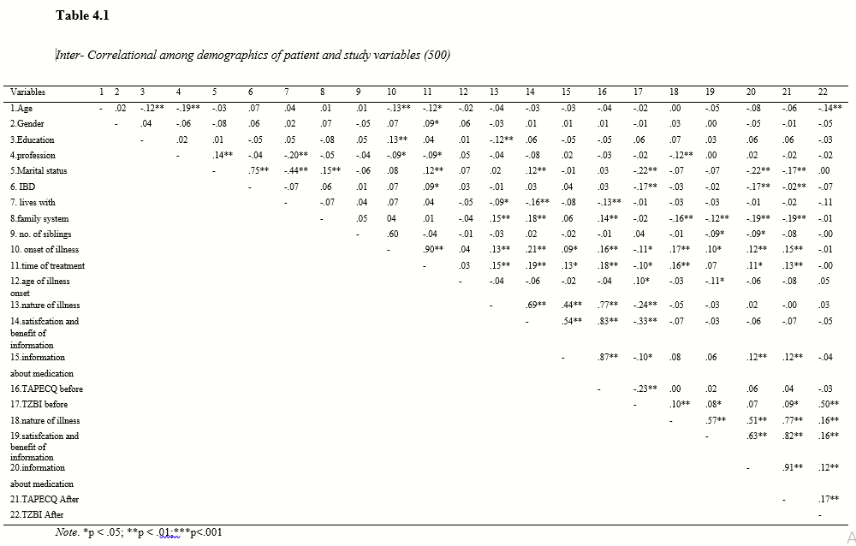

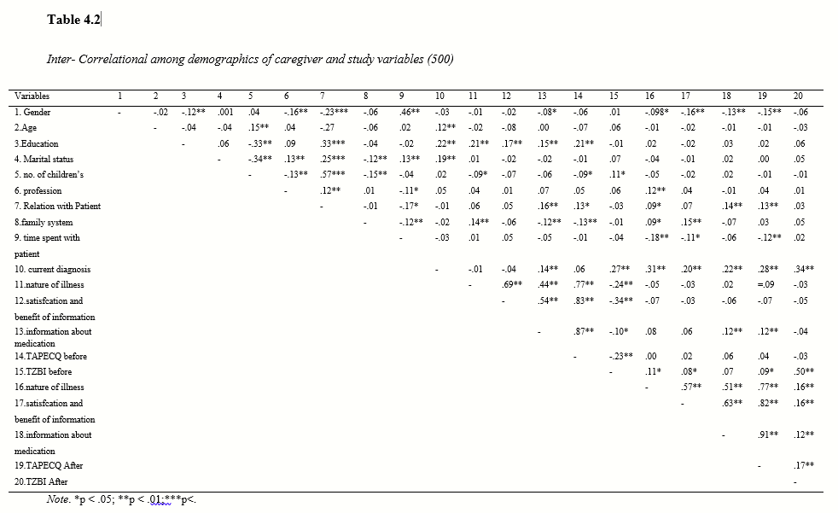

….….
Citation of this Article:
Zohra, N., Ranna, T. & Masood, A. (2022). Psychoeducation and Burden of Caregivers Dealing with Psychiatric Patients. Pakistan Journal of Educational Research and Evaluation, 10(2), 84-92.

