ENGINEERING AND GEOLOGICAL PARAMETERS OF CAMBRIAN AND PRECAMBRIAN ROCKS NEAR ABBOTATABAD AREA, PAKISTAN

Naseem Aadil, M. Saleem Khan, Sadia Sohail
Department of Geological Engineering
University of Engineering & Technology, Lahore
Correspondence Email: naadil@yahoo.com.au

ABSTRACT

A detailed geological and engineering investigation is carried out to find out the geological and engineering properties of Precambrian and Cambrian rock units of Axial belt from Hazara area, Pakistan. These investigations include field geological mapping, field and lab. testing with various techniques such as Total Station, Brunton Compass, Scanline survey and Schmidt Hammer for determining geological characteristics and field strength of rocks. Four formations i.e. Hazara, Tanawal, Abbottabad and Hazira were mapped and engineering characteristics are investigated in this study. Hazara unit of turbidity current deposit consists of slates, phyllite with minor occurrences of limestone and graphitic layers. Some thick bedded fine to medium grained sandstone units is also present. Tanawal formation consists of medium grained quartzite and fine grained mica quartz schist of low grade metamorphism. In the surveyed area, the lower phyllite of Abbottabad Formation is replaced by conglomerate followed by alternating shale, sandstone and dolomite. The formation consists of thick marble beds containing phosphate deposits. The marble is laminated or thin bedded and ranges in colour from white and grey to blue while the Hazira Formation consists mainly of dirty grey and yellowish brown calcareous shaly siltstone. As a result of this mapping, a plunging anticline structure was identified. The field strength of exposed units in the area was established using the Schmidt Hammer technique. Further, slope stability analysis was carried out by applying latest version of DIPS software. The results indicate that the area has gone through light metamorphism due to tectonic activity which is indicated by three major discontinueties in the area. The analysis shows two types of failures (toppling and wedge failure) which can cause damages to the human settlements at the toe of the mountain slopes of Abbotabad area.

Key Words: Field Geological Mapping, Engineering Parameters, Schmidt Hammer Technique, Slope Stability

- INTRODUCTION

The Lower Himalayan Range (also known as the Lesser Himalayan Range or Mahabharat Range) lies north of the Sub-Himalayan Range or Siwalik Range and south of the Great Himalayas. The height of the mountains varies between 1800 to 4600 meters. Millions of years of folding, faulting and overthrusting have led to the formation of these mountains. In Pakistan, these mountains lie just north of Rawalpindi district covering the districts of Batagram, Mansehra and Abbottabad as well as Azad Kashmir. These mountains are also home to Pakistan's important hill stations like Murree, Ghora Gali and Nathia Gali. It snows here during a few months of the year but there aren't any glaciers found in this region. The breakup of the Rodinia resulted in formation of rift basins and passive margins around 650 Ma. Major palaeoclimatic events like Neoproterozoic global glaciation have been recorded from different continents including Lesser Himalaya (Tewari, V.C., 2004). Rocks exposed in the Hazara area in the lower Himalaya belong to Precambrian and Cambrian age. Hazara Slates of Precambrian age provide the basement in the area which is part of the axial belt, lies in the Southern Hazara.

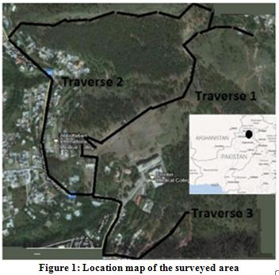
The objective of this study is to highlight not only geological features of the surveyed area but also to discuss joint pattern to decipher engineering characteristics of Cambrian and Precambrian rock units of the Abbottabad area (Figure 1).

2. STRATIGRAPHY OF THE AREA

The units recognized during field mapping are shown in Figure-2. Precambrian and Cambrian rock units of the axial belt of Hazara area is summarized in Table I as discussed in Stratigraphy of Pakistan by Geological Survey of Pakistan (Shah, 1977) and its geological features are discussed below.

Hazara Formation: Hazara Formation is known by different names in the literature however Calkin et. al. (1969) named the unit as Hazara Formation. This unit consists of slates, phyllite with minor occurrences of limestone and graphitic layers. Slates and Phyllites are green to dark green and grayish black on the fresh surfaces however rusty brown, greenish on the weathered surface. Some thick bedded fine to medium grained sandstone units is also present.

Tanawal Formation was named to Quartzose schist, quartzite and schistose conglomerate by Calkin et al. (1969). The unit is well exposed in the south and south eastern margin of “Mansehra Granite” and in a narrow belt of north west along the western flank of the Balakot Syntaxis. To the south of Mansehra Granite, the unit consists of medium grained quartzite and fine grained mica quartz schist. The grade of metamorphism increase in the northward direction (Calkin et. al. 1969). The Tanawal Formation underlies the Abbottabad formation and overlies the Hazara Formation. The contact between Abbottabad and Tanawal is marked with unconformity which is represented by Tanaki Conglomerate. Tanawal Formation is devoid of fossils and the given age is Cambrian based on correlation.

Abbottabad Formation was named by Calkin et al. (1969) based on exposures near Abbottabad which consists of dolomite, quartzite and phyllite with interfingering shale facies. In the surveyed area, the lower phyllite unit is replaced by conglomerate followed by alternating shale, sandstone and dolomite. The formation consists beds of thick marble containing phosphate deposits. The marble is laminated or thin bedded and ranges in colour from white and grey to blue. The age of the formation is considered as lower Cambrian based on fossils found in the Abbottabad area.

Hazira Formation is well exposed near the village of Hazira in Hazara area and consists mainly of dirty grey and yellowish brown calcareous shaly siltstone. The yellowish colour become reddish near Banda Pir Khan where the formation contains glauconitic facies near the base. The Cambrian age is given based on fossils which are also found in Cambrian of Australia. Rushton (1973) confirmed Cambrian age for Hazira Formation.

Table 1: Salient Features of Precambrian and Cambrian rock units of the Axial belt in Hazara area of Pakistan

Age | Formation | Salient Features
Cambrian  Cambrian  Cambrian  Precambrian | Hazira Formation  Abbottabad Formation  Tanawal Formation  Hazara Formation | Reddish siltstone, Glauconitic Facies  Dolomite. Quartzite, Phyllite  Quartzite, & mica quartz schist  Slates, Phyllite with inter bedded shales, minor limestone and sandstone

GEOLOGICAL FEATURES

Folds: A number of geological features were observed in the surveyed area. The key features include fold, faults, and joints. Prominent folds such as anticline, syncline, chevron, recumbent were well exposed and dipping in the NE direction (Plates A & B).

Faults: Normal, reverse and thrust faults were observed with an average throw from a few centimeter to 2 feet. Some microfaulting are also observed. The opening of fault planes is filled with gouge material which is highly weathered and argillaceous. The average opening of fault planes is 1-2 inches (Plate C).

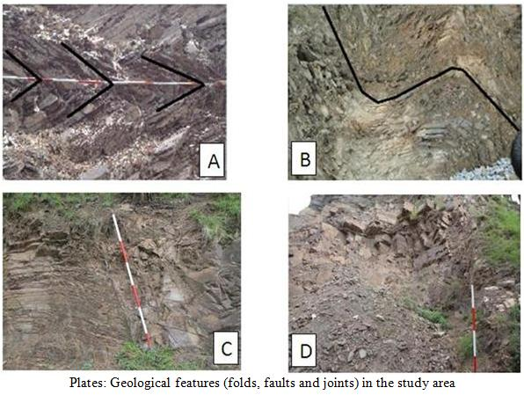

Joint Patterns: A number of joint sets were observed in all four formations. Persistent and non-persistent, both types of joints are observed. The persistent joints cross throughout the succession and an indicator of single episode of tectonic activity. However, non-persistent joints indicate different phases of tectonic activity and do not pierce in the whole section. Some cross and oblique joints are also observed which normally give wedge failure (Plate D).

Regional Structures

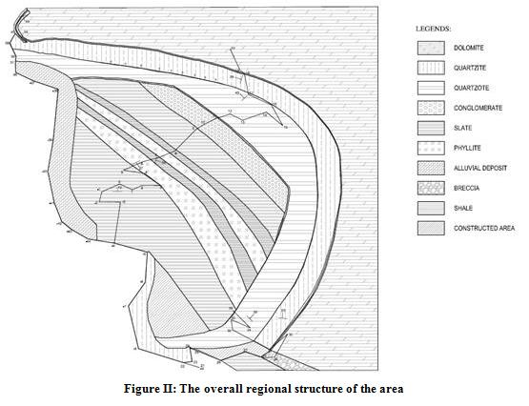
The overall regional structure of the area exhibits two very large and one medium sized fold (Figure II). The medium sized Fold is a plunging anticline, tilted to the left, plunging in the North-East direction. The Fold consists of 3 units; Phyllite, Slate and Shale. Phyllite is the oldest, and occupies a central position at the core of the Anticline. Above it lays the Younger Slate, which is overlain by the youngest Shale. One of the larger folds is another Anticline, which dwarfs the medium sized anticline beneath it. Its Axis strikes parallel to the axis of the smaller anticline. This obviously means that both anticlines are plunging in the same direction with the same amount, and both have the same amount of tilt. The top of the larger anticline is occupied by the youngest dolomite. Next comes the older Quarzite, which is underlain by the yet older Quartzose. Shale, Slate and Conglomerate follow in succession, which indicate that these units are neither part of the larger anticline, nor part of the smaller one. There is a chance that these layers have been deposited as an Unconformity between the two anticlines.

The other large body is a plunging syncline, lying adjacent to the larger anticline, with its axis, Plunge Angle, and Tilt being the same as that of the two anticlines. The lithological units of the syncline are the same as that of the larger anticline (Figure II).

Localized Structures

A number of localized folds and faults were observed throughout the area. one localized syncline was observed in Shale while another localized syncline was marked in weak Slate. Along the main traverse, a number of faults were marked. Two parallel joints were disturbed by a perpendicular fault, which produced a throw of about 9 inches in both upper and lower joints. Due to the small amount of throw, the bedding on both sides of the fault doesn’t show considerable change. A joint occurs above this fault at right angle, which doesn’t show any movement. So, this Joint can be thought of as having been formed after the localized tectonic activity. In addition, 6 small faults were observed in Quartzose which clearly exhibited Horst and Graben Structures.

A small heap like outcrop of Slate was encountered on the right side of the road. In that heap, a small sized Recumbent-Chevron Fold was observed (Plate A). Micro-folds were observed in Slaty-Shale.

ENGINEERING FEATURES

Strength of Formations
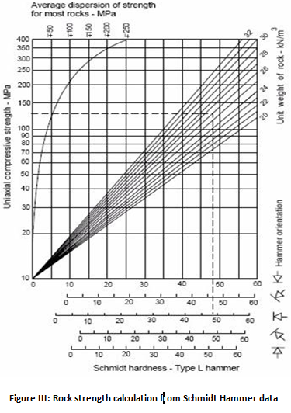
The strength of rock units is assessed in the field using Schmidt Hammer (SHV) technique (Figure III). These values were taken at different locations and angles to gain accurate results. SHV were taken both along bedding and joint planes. SHV in slates of Hazara Formation range from 10-20 while in Phyllite, these values range from 20 to 25. SHV of quartzose range from 38-48 while these values exceeds 50 in quartzite as show in Table 2. A small breccia unit exposed at traverse T2 is very tight has SHV range from 40-50.

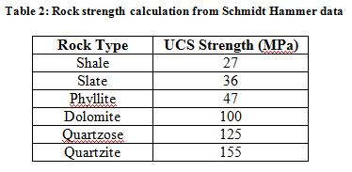

Rose Diagram Plot

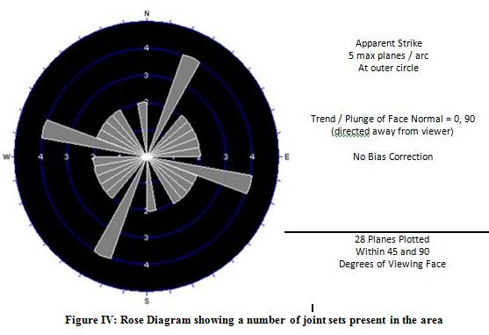
The twenty eight joint patter data used to plot Rose Diagram as shown in Figure IV. The Rose diagram indicates that there are a number of joint sets present in the area which highlight the tectonic setup and engineering properties of rock formations. Five discontinuities are dominant in the area with two major planes cross each other at N20E and N85W. Wedge failure identified in the field is also confirmed with this diagram. In short, the Rose diagram indicates a moderator fractured zone with significant numbers of joint patterns. The study is comared with Hammah (1998).
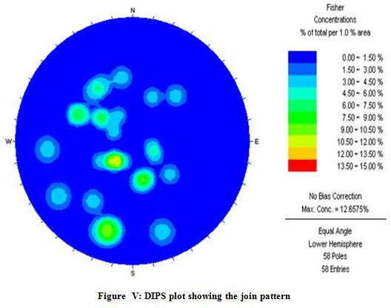
Stereonet Plot

The contour plot for 28 planes measured in the field are plotted with DIPS software shows that sixteen contoured clusters in NW and SW areas confirm the joint pattern observed in the Rose diagram. The plot indicates that the study area is moderatory fractured however the maximum are indicated almost in the middle of the Figure V.

Conclusions

Based on this study, following conclusions are drawn.

- The surveyed area indicates a northward trend of low grade metamorphism indiacted by shale, slate, phyllite, schists etc.
- The formations sequence ranges from shale to quartzite with increasing strength
- The effect of tectonic activity is high indicated by the presence of fold, faults and joints. Cyclic tectonic acivity is confirmed on the basis of a number of recumbent folds in the area.
- The joint pattern indicated the moderator fractures zones which are confirmed from the stereonet plot. Further, wedge failure is expected in the outcrop cliff.

REFERENCES

- Aziz, M., M.U. Qureshi, Y. Sugru. Geotechnical investigations of weathered slopes in Muzaffarabad area after the 2005 Kashmir-Earthquake Journal of Harbin Institute of Technology, China , 16, Sup-1 (2009).
- Calkin J.A., T.W. Offield, S.K.M. Abdullah and Ali Shah Tayyab. Geology of the southern Hamalya in Hazara, Pakistan and adjacent areas. USGS Prof. Paper 716, 29p (1975).
- DIPS Software Department of Computer Science University of Illinois (2006).
- Hammah, R.E. and J.H. Curran. Fuzzy Cluster Alogrithm for the Automatic Identification of joint sets. Int. J.Rock Mech. Min. Sci. 35, 889-905 (1998).
- Khan, M.S., I. Ahmad, S.R. Ahmad and M.A. Qadri. Slope stability analysis in hard rocks and prediction of landslide along Khewra Choha Saidden Shah road Salt Range Pakistan, Pakistan Journal of Science. 63(4), 232-235 (2011).
- Shah, S.M.I. Stratigraphy of Pakistan. GSP, Memoir 22, Geological Survey of Pakistan, Quetta (2009).
- Tewari, V.C. Microbial diversity in Meso- Neoproterozoic Formations, with particular reference to the Himalaya. In: J. Seckback (Editor) Origins. Kluwer Academic Publishers. Printed in the Netherlands. Pp.515-528 (2004).

