Identity Conundrum: Content Analysis of Social Studies Textbooks
Ashar Johnson Khokhar
__________________________________________________________________
Abstract
The beginning of the 21st century has seen a surge in the nationalistic political movements and education is an important tool employed by the state to transform the nationalistic narrative of a country. South Asia is no different from it. Pakistan like other South Asian countries has built its own national narratives which are promoted through school practices, curriculum and textbooks. This study examines the content of Social Studies textbooks published by the state textbook boards to identify the nationalistic narrative communicated to learners. The textbook writers have employed various discourse strategies to propagate and sustain the nationalistic narratives. This study has found the textbook writers using intentional and unintentional differentiation and unification, transformation and homogenization, assimilation and dissimilation and positive 'self- presentation’ and the negative 'other'-presentation discourse strategies. This study suggests to textbook writers to remain aware of the discourse strategies used and how these influence the learners and shape their national identity and identity narrative.
Keywords: Textbooks, social studies, curriculum, identity, textbook boards
Introduction
Identity has gained importance as we approach the closing of the second decade of the 21st century. The countries ruled by the populist movements and populist political parties is increasing and a tension is visible between the Populist and those calling themselves the mainstream political, social, cultural and religious groups. Factors such as race, religion, language and political philosophies are forming what could be called a national culture, national character, nation-ness or nationhood (Anderson, 2006). A nation was seen to be formed because of a set of natural and objective things they ascribed to (Eley & Gellner, 1984) and these formed their collective but relatively permanent behaviours and attitudes. It was argued that the essential behaviours that shape identity start taking shape at birth and most of them remain unchanged throughout the life of a nation. The national character, as Mallinson (1975) saw it as "the totality of dispositions to thought, feeling and behaviour peculiar to and widespread in a certain people, and manifested with greater or less continuity in a succession of generations" (13).
The primordialist and perennialist paradigms of identity which existed until the 1960s saw identities as “ubiquitous, natural and ineffable” entities with intrinsic values that have existed throughout the recorded history of a nation and this did not go through a dramatic change throughout the history of a nation argues Klerides (2010). This set of identities existed irrespective of education and formal schooling systems and practices. The education system and practices were created to preserve, perpetuate and transfer the characteristics that would create a strong bond amongst those who will participate in the educational system. Mallinson (1975) argued that through “education of the immature” societies have been striving to “protect and perpetuate” their “traditions and aspirations” (p. 8). The creation of and sustaining an education system represents the national character of a nation and it distinguishes a nation from other nations.
The era of the 1950s and 1960s saw many studies (Eley & Gellner, 1984; Foucault, 1980; Gramsci, 2001) highlighting how language, culture, colonization, colonial structures and economic systems were used by the powerful to perpetuate their hegemonic control over the weak. Education as a tool of reproduction of a certain colonial culture was the common strand in all these studies. These studies argued that school content and practices revolve around the colonial structures and settings thus reproducing the culture of the colonizer and the culture of the colonized is left out of this exercise of formal schooling systems and practices. This led to what is now called a modernists view of national identity. Hall called it deconstructing national identities and cultures (Hall, 1992) while Smith called it a new paradigm of the origin of nations (Smith, 1999). The modernist paradigm saw national identity as a social constructedness of nations, an imagined community (Anderson, 2006).
The modernist view of nationhood and national identity claimed that the identity of a nation cannot be disconnected from its past, but it cannot remain anchored there for time to come. National identity is considered as a mental construct promoted through a common and shared imagery. This imagery is related to physical boundaries of a nation giving a sense of autonomy and control over a certain part/area of land concealing actual divisions and heterogeneity within those living within these boundaries. The imaginary boundaries extend beyond physical boundaries to human activities (memory, fantasy, myth, desire and fetishism) and produce one common identity, which is not confined to apparent differences but how these communities imagined themselves, finding commonalities that bound them together (Anderson, 2006; Billig, 1995; Hall, 1992).
Narration, as described by (Bhabha, 1990) and Martin (1995) is used to construct identities. Bhabha (1990) believes that nations “lose their origins in the myths of time and only fully realise their horizons in the mind's eye. Such an image of the nation - or narration - might seem impossibly romantic and excessively metaphorical, but it is from those traditions of political thought and literary language that the nation emerges as a powerful historical idea” (p. 1). Martin suggests that “identities by themselves do not exist, they are constructed by identity narratives” (1995, p. 7). The stories and the characters of a story treat a nation as a character and as Benwell & Stokoe (2006) argue, that the national character is being formed through the characters and the plot of the stories. The national narratives also show the multiplicity of identities as Ozkirimli (2010) suggests that different social groups of the nation promote ideas of nationhood which are often conflicting and Wodak et al (2009) believe that one national identity does not exist as groups construct their plural identities which occurred due to contested narratives pulling the readers to different directions. Hall called it “fragmented and fractured” (1996, p. 4) moving back and forth between the promordialist, essentialist, perennialist and modern views of identity, move between reality and fiction as Smith (2003) suggests.

Pakistan
The education policies of Pakistan since 1947 have perceived education as a tool and a process to create national belongingness and cultural preservation. The Planning Commission’s ‘Vision 2030’ dreams of Pakistan as enabling youth to contribute in the development of Pakistan and also to develop in them a sense of Pakistani nationhood, the concepts of tolerance, social justice, democracy, their regional and local culture and history based on the basic ideology enunciated in the Constitution of the Islamic Republic of Pakistan (Government of Pakistan, 2009, p. 10). The latest education policy (Government of Pakistan, 2017) also focuses on promoting nationhood and national integration. This document has summed up the purposes of the teaching of Social Studies as
- Promote and foster ideology of Pakistan creating a sense of Pakistani nationhood on the principles of the founder of Pakistan i.e. Unity, Faith and Discipline.
- Foster the ideals of Muslim Ummah. Cultivate inter-faith harmony and celebrate diversity of faiths.
- Promote the values of peace, tolerance, respect for human rights, universal brotherhood, understanding and mutual co-existence (2017, p. 10)
Academics and researchers have been researching Social Studies/Pakistan Studies textbooks since the 1990s. The studies by Aziz ( 1993c, 1993a, 1993b) identified historical errors in Pakistan Studies textbooks and textbooks. The Sustainable Development Institute of Pakistan, known as SDPI, undertook a detailed study of textbooks (2005) published by the textbook boards in Pakistan and identified historical errors and texts depicting biases in the textbooks. This is considered a very important and detailed work in Pakistan. There are many other researchers such as Saigol (2005, 2010) who focused on two aspects in her studies, gender and Us vs Them. She studied civics and Social Studies textbooks and highlighted how these textbooks keep reminding women of their responsibilities and not informing them about their rights. She also looked at the Social Studies, Pakistan Studies and Civics textbooks (secondary level) and explored how Us and Them is presented, internal and external; Bernadette L Dean’s work (2005, 2008) focused on social studies and civics textbooks and social cohesion. Her studies focused on the Sindh Textbook Board’s books and some private publishers whose books were taught in the Sindh province. She also worked with teachers teaching Social Studies and tried to explore their problems and issues related to textbook content and their pedagogical practices and how schools facilitated them in teaching Social Studies to promote social cohesion. Rosser (2004; 2003) focused on three big South Asian countries (Bangladesh, India and Pakistan) and she studied how social political and religious influences are shaping textbooks through the content omission (contend omitted from the textbook), elision (bland representation of events or people) and embellishment (using colourful language to describe events and people in textbooks). Her focus was Us vs Them in these three countries. The focus was social studies textbooks; Naseem (2014; 2006) in his studies looked at Urdu and Social Studies textbooks to highlight the gendered subjectivities through the text. He has also looked at how Urdu and Social Studies textbooks are used to promote militarism and militaristic subjects leading to conflicts and how discourses are used to counter the prevailing militaristic discourses in schools and society through textbooks; Lall’s (Lall, 2008, 2012, 2014) work explored how Indian textbooks (during BJP led government 1998-2004) and Pakistani textbooks (during Zia’ regime 1977-1988) evolved. The focus was to see how history was rewritten in both countries during this time, which included, finding a suitable text to suit their ideology, which included hating the other. She also looked at two paradoxical identities. She used a questionnaire and collected data from all provinces of Pakistan from schools, colleges and universities students and found two interesting phenomenon, a high sense of belongingness to nation and a high sense of alienation from state leading to low level of participation in the political process; Durrani’s (Durrani, 2008, 2013; Durrani et al., 2017; Durrani & Dunne, 2010) work has focused on peace building and social cohesion. One of her studies included textbook analysis which was focused on KPK. She analysed images drawn by students of classes 4-5 about themselves (depicting themselves as Pakistanis) and others (depicting the enemy). She found the drawn images deeply embedded in religion and it was difficult to separate identity from religion and here she raised questions of social cohesion amongst different religious groups in Pakistan.
The most recent studies are by Raina (2014a, 2014b), Chughtai’s (2015), Muhammad (2015), Khan (2016) and Durrani (2017). Chughtai (2015) looked at how textbooks are designed and how different forces influence the selection of the textbook content and how this content shapes students’ identity. She looked at 122 textbooks starting from 1938-2012. She used war in history (how wars are presented in textbook); religious ideology (whose ideology is given preference and whose is missed out); political power (the agenda of different political forces to keep the federation intact, curriculum reform agenda of 2002 & 2006 constructs. The focus was Punjab Textbook Board’s social studies, history and Pakistan studies textbooks; Muhammad’s (2015) studied the effects of national curriculum 2006 on textbooks and teachers’ pedagogical practices. He studied classes IX-X Punjab Textbook Board’s Pakistan Studies textbooks and interviewed teachers; Gulab Khan’s thesis (2016) used data from a conference conducted after the 18th amendment in Pakistan and he analysed the discourses of this conference which were about History textbooks and curriculum; Raina (Raina, 2014b, 2014a) looked at the religious minorities’ representation/misrepresentation/no-representation in the legislative content and textbooks content.

Research Methodology
This paper uses the analytical framework derived from Billig (1995), Smith (2001, 2003), Hobsbawm (1996), Eley and Gellner, (1984); Gellner, (1983) and Bourdieu (1994).
The first element of the analytical framework is a common national space. A nation is an imagined community living in a physical place, they call their homeland and “a landless nation is a contradiction in terms” (Smith, 1999, p. 149). Billig (1995) and Smith (2003) argued in their work that narratives building identities present the geo-body of a nation’s identity in multiple ways, a sacred homeland with clearly defined borders beyond those borders lie a different nation; a land imagined with a history and ancestral connection and spiritual bond between the land and its people; a land imagined as beautiful, unique and self-sufficient clearly separating ours from theirs. This imagined space is called the territorialization of memory which uses historicization of nature (the land with all its natural features are contributing factors in the historical and cultural growth of a nation) and the naturalization of history processes (the culture and history are derived from the natural features of a land).
The second element is a collective national time. It is argued by Smith that “If nations exist in space, they are equally anchored in time” (2003, p. 166). The national time is further divided into three sub-elements, past, present and future. It is believed by a nation that their nation has a long history that goes back to unknown and obscure ancestral generations and at the same time they look with hope for a better and more prosperous generations of descendants (Calhoun, 1993, 2007; Miller, 1995; Smith, 1999, 2003). The past is an important element that shapes a nation and this also justifies their present and their future in the light of their past and historians create the past narratives and bring the imagined heroes and villains into life in the stories imagined, told and retold generation after generation. The focus of these stories is to communicate to the readers the uniqueness and superiority of their national culture and the racial and cultural purity, the longevity and continuity of their national identity in time. The historians use a set of tales, events, symbols and people sharing a nation’s sorrows, triumphs, defeats and shared experiences.
A shared national culture is the third element of the analytical framework. The modern man is different from his ancestors who were loyal to a monarch, a land, a faith, a culture; the modern man has multiple identities based on many artefacts of both high culture and the popular culture. The national culture of a nation is presented in the great works of literature, painting, philosophy and music (high culture) and to mass oriented forms of music, art, design and literature (popular culture) (Martin, 1995).
The fourth element of identity construction framework is a common national habitus. "National identity has its own distinctive habitus which Bourdieu defines as a complex of common but diverse notions or schemata of perception, of related emotional dispositions and attitudes, as well as of behavioural dispositions and conventions” (Wodak, 2006a, p. 1234). The notion of national habitus is preferred over national character. The latter is inherent and eternal while the former is internalized and individually acquired due different socialization processes. The national habitus is not just about ‘us’ and ‘them’ but goes beyond and talks about standing with one’s nation in time of struggle and protecting it from threats to its existence and continuation.

Table 1
Four elements defining national identity
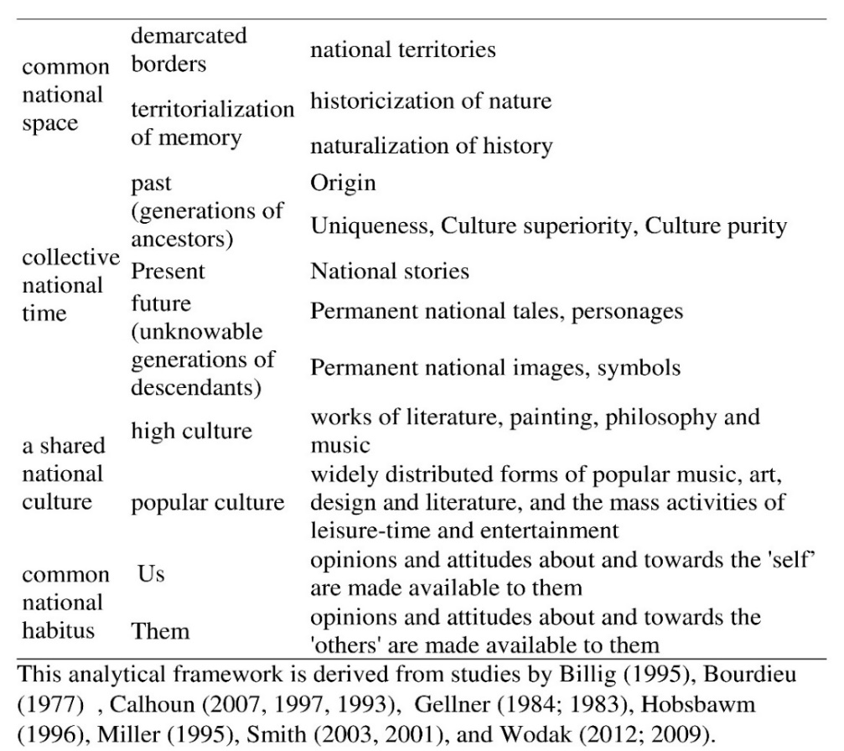
The social theory on discourse and linguistically-oriented discourse analysis is used to anlayse the social studies textbooks published by the textbooks boards in Pakistan. It is argued that discourse analysis is a useful approach to understand the identity construction process in schooling, especially through Social Studies (inclusive of history and geography). Discourse also works as a bridge between the two ideas, that is, social theory of discourse and linguistically-oriented discourse analysis. These approaches as suggested by Eley & Suny have proved to be a catalyst in moving the study of nationhood into what Smith calls “realm of discourse and the generation of meaning” (1996, p. 6). Benwell and Stokoe have explained how social engineering is used to construct identity and how elements of metanarrative are used in historical content. It is suggested that identity is “actively, ongoingly, dynamically constituted in discourse” (2006, p. 4); for Wodak et al., “national identities, as special forms of social identities, are produced and reproduced, as well as transformed and dismantled, discursively” (2009, p. 3). Bernstein’s idea of recontextualistaion suggests that discourse changes as it moves from outside education, original site of production of discourse, to educational discourse (textbook content and pedagogised knowledge for transmission). This does not change the discourse but only changes the original order of the discourse. Cowen has argued that the discursive construction of national identity does not gloss over "history, culture, conflict and education” (1996, p. 149) but presents them through intellectually interesting and stimulating narratives. Broadfoot (2000) says that discursive construction of identity builds bridges between multiple disciplines at micro and macro levels of analysis.
The first level of analysis is the level of topics. Discourse analysis is the preferred choice as it reveals the thematic choices and the messages encoded in the nationalist discourse organized around four categories discussed above (time, space, culture and habitus).
The level of strategies is the second level of analysis. Discourse analysis explains that writers and speakers plan and use consciously or unconsciously, strategies to convey messages of national unity and differences (time, space, culture and habitus) along with other strategies to communicate nationalist messages such as continuity, uniqueness, superiority, autonomy. These strategies are used with the intention to maintain, defend and reproduce an identity. These strategies are rooted in discourse as constructive, transformational and perpetuating functions (Wodak, 2006b). The other set of strategies used here is of detachment or involvement; mitigation or intensification (Wodak et al., 2009). The former shows how writers or speakers have been detached or involved in a nationalist discourse while the latter looks at how the nationalist proposition is expressed and its commitment to truth.
The linguistic means and devices used in the expression of the contents and strategies is the third element of analysis. Benwell and Stokes (2006) argue that these two "are connected via the process of 'realisation': Iexicogrammar 'realises' semantics, the linguistic 'realises' the social layers, content and strategies” (2006, p. 108). The lexicon of identity is used to realise a nationalist discourse as Billig (1995) says “the crucial words of banal nationalism are often the smallest: 'we', 'this' and 'here', which are the words of linguistic 'deixis'” (1995, p. 97). Language (words, phrases), language devices and strategies are used to construct narratives of time, space, culture and habitus and many others such as unity, continuity, difference, singularity etc.

Findings and Discussion
General layout of the textbooks
The social studies textbooks are divided into chapters and each chapter focuses on a single element. The first chapter of all the textbooks under study in this study focuses on general geography and covers topics such as map reading skills and basic information about the world. The order of the remaining chapters of the textbooks differs for each provincial Social Studies textbook. All the textbooks have content covering all the four elements being studied in this study.

First element – common national space
The textbooks have covered this area. The content of each textbook explains the territorial boundaries and how they have shaped the history of the people living in each province. The content has focused on provincial history. The physical features of each province are embedded in the local population. The professions of the population are based on the territorial nature of each province. The location of Pakistan is considered strategic because Pakistan shares borders with Afghanistan, China, India and Iran. Pakistan was divided into two separate states, the separated part is now called Bangladesh. This re-drawing of borders with India has made India as the ‘other’ in the textbook, until today. The border and location of Pakistan has played a positive and negative role in Pakistan’s history. A positive role due to China and Iran’s friendly relations and no trouble on the border with these countries and a negative role because of not so friendly border with Afghanistan and Indian aggression and invasion and the continuing status of the disputed state of Jammu and Kashmir. The content presents Pakistan’s location an ideal and very attractive and desirable because of the old silk route which was once again developed by China under the One Belt One Road project. A system of communication is being developed, both roads and railways which will connect China with Europe through Central Asian states to Russia and from there to Europe. The adjectives such as important, significant, friendly (positive image), enemy, rivalry (negative image) are found in the content.

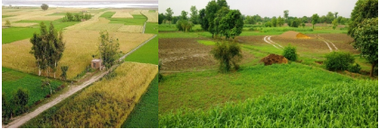
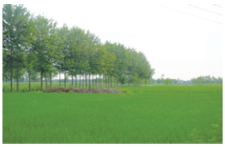
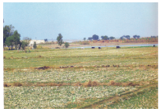
Figure 1. Images of Pakistan given in SST textbooks (A fertile land)
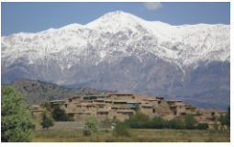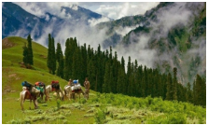
Figure 2. Images of Pakistan given in SST textbooks (mountainous and lakes)
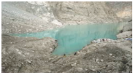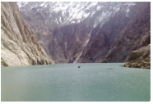
Figure 3. Images of Pakistan given in SST textbooks (deserts)
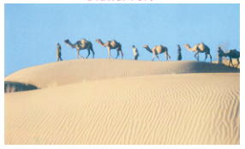
Figure 4. Images of Pakistan given in SST textbooks (coastal belt)
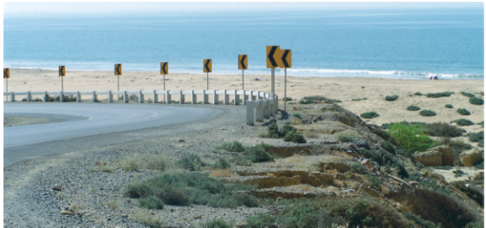
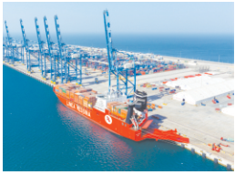

Second element – collective national time
The textbooks give a prominent space to this element. There are three to four chapters covering this element as compared to just one chapter allocated to the first element. The past has looked at the history of each province (see Table 2). The chapter has also highlighted the contribution of different people and their role in different events happening in the land now part of each province. The names, most of them, are common in all SST textbooks except few differences and this is due to the influence of politico-religious parties on textbook content selection. For example, Khyber Pakhtunkhwa Textbook Board’s SST class 4 textbook has mentioned Qazi Hussain Ahmed (Khyber Pakhtunkhwa Textbook Board, SST class 4, p. 54), who was head of the religo-political party was part of the ruling coalition in the Khyber Pakhtunkhwa province and was given the Education Ministry in the province as this was one of the their demands to form a coalition to form a government in the Khyber Pakhtunkhwa province. The Sindh Textbook Boards’s Class 4 SST has highlighted Zulfiqar Ali Bhutto and Benazir Bhutto as great democratic leaders of Pakistan as they are mentioned as becoming head of the government as a result of general elections (pp. 70-71). One must remember that the political party formed by Zulfiqar Ali Bhutto has been ruling the Sindh province for the last 11 years. The national stories and heroes are also representative of each province. The regional heroes and regional tales of success are shared with the students. Pakistan in the future is viewed as a strong and prosperous country with its young people playing an important role in it. Regional politics plays an important part in selecting the heroes and the important national stories. For example, KPK textbook has included a leader a religio-political party in its chapter titled “Important Political Leaders of Khyber Pahtunkhwa Province (Khyber Pakhtunkhwa Social Studies Class 4, p.54) which shows the influence of that religio-political party. Religion is presented as a force shaping the history of the land and its people.
The various Muslim rulers’ contribution is highlighted in the development of social, cultural and political systems in India. Each textbook has a chapter on the life of Prophet Mohammad and one chapter discusses the life stories of early Muslim rulers called first four pious caliphs. These chapters connect the culture and history of Pakistan, Bangladesh and India to Islam and its positive contribution in making these places better for all. The history part of SST textbooks traces the roots of the Pakistan movement in the coming of Muhammad Bin Qasim to the subcontinent in 712 AD. The textbooks do not inform students about rulers, people, their culture, before 712AD (Hindu rulers, the society under them, important social, cultural and religious events, achievements of these rulers and societies, etc.) except highlighting how advanced subcontinent was under Buddhist rulers, that is, during Indus Valley and Gandhara civilisations. The history moves fast to 712AD from the Indus Valley and Gandhara civilisations (Sindh Textbook Board Class 4 SST, p. 16-17; Punjab Textbook Board Class 4 SST, p. 12-14), skipping many centuries between these two times. It appears from the selection and presentation of the content that that the big gap between Asoka and Muhammad Bin Qasim is not an omission but an intentional effort to not to have anything positive about those who rules and were rules in the subcontinent. The society during this time period (Hindu rule) is described as divided into castes system (Sindh Textbook Board’s Class 4 SST, p. 18); and the custom of satti (a married Hindu woman killing herself with her deceased husband).
Table 2
History of Province
Textbook Board | Class | Chapter Title | pages
Punjab | 4 | History: Our Past | 15-33
 | 5 | Our History | 26-38
Sindh | 4 | History of Sindh | 14-28
 | 5 | The Struggle for Independence  Important People and Events in the History of Pakistan and the World | 53-63  64-77
Khyber Pakhtunkhwa | 4 | Tareekh (History) | 23-65
 | 5 | Tareekh (History) | 46-79

Third element – a shared national culture
This element is also given two chapters to inform students about the provincial and national cultural heritage of each province of Pakistan. These chapters talk about various types of regional music, food, dress, festivals (religious and non-religious) and dances. The national culture is shown as composed of all provincial cultures. Islam as a religion and a force is presented as a force shaping the culture of the Indian subcontinent (undivided India), especially the areas which are now part of Pakistan. The images depicting the culture of each province shows men, women and children wearing shalwar kameez (national dress), with women and girls covering their heads. The cultural aspect is covered in one chapter which highlights different cultural elements such as dresses (see Table 3), food (see Table 4), religious (Eid and Urs) and non-religious (cultural and social) festivals (see Table 5). The textbooks have a chapter on Pakistan cultures which explains to students different types of religious (see Figure 5) and non-religious (see Figure 6) festivals and celebrations.

Table 3
Dresses
Textbook Board | Class | Chapter Title | Page(s)
Punjab | 4 | Culture: The Way of Living Together | 50, 51, 53
Punjab | 5 | Culture | 53
Sindh | 4 | The Way We Live Together | 69, 72, 74, 76
Sindh | 5 | Culture | 80
Khyber Pakhtunkhwa | 4 | Culture | No images are given (religious)
Khyber Pakhtunkhwa | 5 | Culture | No images are given  (non-religious)
Table 4
Food
Textbook Board | Class | Chapter Title | Page(s)
Punjab | 4 | Culture: The Way of Living Together | 53
Punjab | 5 | Culture | 53
Sindh | 4 | The Way We Live Together | 70, 72, 75, 76
Sindh | 5 | Culture | 79
Khyber Pakhtunkhwa | 4 | Culture | No images are given (religious)
Khyber Pakhtunkhwa | 5 | Culture | No images are given (non-religious)
Table 5
Religious (Eid and Urs) and non-religious (cultural and social) festivals
Textbook Board | Class | Chapter Title | Festival / Page(s)
Punjab | 4 | Culture: The Way of Living Together | 51 & 52 (religious)
Punjab | 5 | Culture | 53 (religious)  50, 51 (non-religious)
Sindh | 4 | The Way We Live Together | 71, 73 (religious)  71, 73, 75, 77, 78 (Non-religious)
Sindh | 5 | Culture | 81 (religious & non-religious)
Khyber Pakhtunkhwa | 4 | Culture | No images are given (religious)
Khyber Pakhtunkhwa | 5 | Culture | No images are given (non-religious)

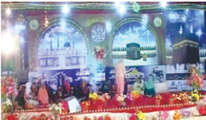
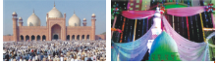
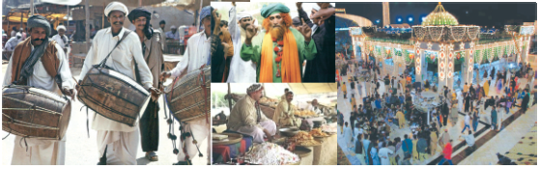
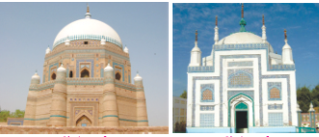
Figure 5. Different aspects of Pakistani culture in SST textbooks (religious)
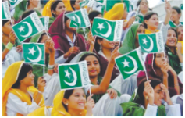
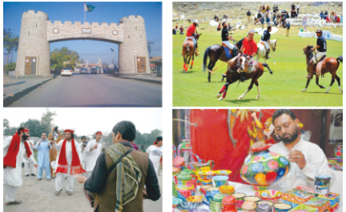
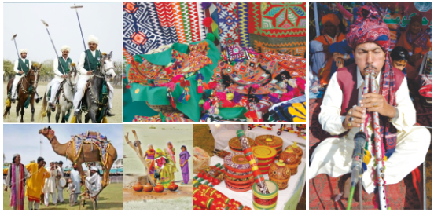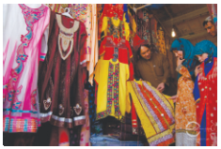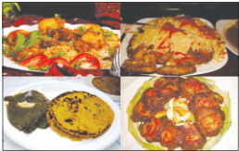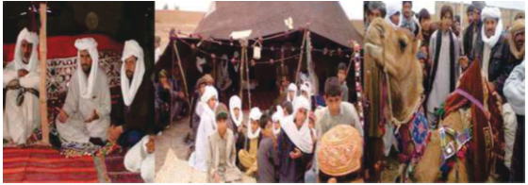
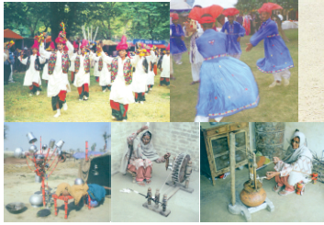
Figure 6. Different aspects of Pakistani culture in SST textbooks (non-religious)

Fourth element – common national habitus
This element exists throughout the social studies textbooks where people, their culture, customs, traditions are divided along Us and Them. This specifically appears in chapters focused on element two and three. The distinction between Us and Them is visible in chapters informing students about the rulers of the Indian sub-continent. The advent of Islam and the establishment of the first Islamic kingdom in the Arabian peninsula is considered an important event in human history. The expansion of the first Islamic city state is believed to be due to the superiority of the Islamic faith and its followers. The conquest of Sindh is given an important place in all textbooks and it is presented as a symbol of the victory of Islam over a non-Islamic kingdom in South Asia and the introduction of Islam.

Strategies employed
The writers have used many strategies to emphasize and reinforce the ideas. The strategies are positive self-presentation vs negative other-presenation; assimilation vs dissimilation; transformation vs homogenization; and differentiation vs unification.
The positive 'self- presentation’ and the negative 'other'-presentation is evident in the text. The strategy used here is of distinguishing the 'self' and the ‘other.’ The society emerging after the Muslim conquest is presented as better than the society which existed before the Muslim conquest under Hindu rule. The representation of pre-Islamic society in the Arabian peninsula and in South Asia is presented as divided along caste and groups, rulers and ruled. Through these strategies, a symbolic comparison is drawn between the superior by using the words ‘justice’, ‘prosperity’, ‘progressive’ and inferior through ‘backwardness’, ‘poverty’, ‘untouchable.’ The narratives of good spreading throughout the Arabian peninsula and South Asia is presented as prosperity and justice spreading throughout the kingdom.

Examples of positive self-presentation and negative other-presentation
Example 1: The Alexander coming to the subcontinent is called ‘invasion’ and he is presented as ‘proud man’ who wanted to ‘take revenge’ from the Persians. He reached Punjab through Khyber Pakhtunkhwa but ‘brave’ Raja Porus fought and Alexander was wounded and decided to return to Greece after handing over the authority to Raja Porus. (Punjab Curriculum and Textbook Board, 2017, p.14).
Example 2: The other non-Muslim (Buddhist) King who is praised is Ashoka. He was a “great king” who kingdom covered most parts of the subcontinent. He is “Indian native” and a “wise ruler” (Punjab Curriculum and Textbook Board, 2017, p.15).
Example 3: The very first Muslim who defeated the local king was Muhammad Bin Qasim who arrived in the 8th century. The local king is presented as cruel who would attack ships carrying people and cargo and confiscate everything on the ships. Muhammad Bin Qasim is presented as someone who treated non-Muslims “well” and let them live according to their religion (Hindu religion). The textbook content also says that Muhammad Bin Qasim award land to Hindu and Buddhist leaders. This behaviour made many local (Hindu and Buddhist) to convert to Islam.
Example 4: The textbooks jumps to 11th century and inform students about the conquests and rule of Mahmood Ghaznavi. He is also credited with bringing Muslim Sufis to the subcontinent and this lead to the conversion of local people in large numbers. The others rulers are credited with many achievements in the subcontinent such as Grand Trunk Road, Taj Mahal and establishing best administration structure (Punjab Curriculum and Textbook Board, 2017, p.19).
Example 5: The textbook talks about Sikh religion and its founder Baba Guru Nanak as present him as someone influenced by Muslim Sufis and teachings of these Sufis are part of the Sikh religion. There is an indirect reference to Hindu religion when the textbooks say “He did not like the worship of idols and believed in one God” (Punjab Curriculum and Textbook Board, 2017, p.17). The textbook does not inform students about the wars between Sikh religious leaders and the Muslim rulers and how Muslim rulers felt threatened from Sikh religion and its followers in Punjab. There is an image (see Figure 7) where contains the pictures of the heroes of Pakistan. The picture includes Muhammad Ali Jinnah (Founder of Pakistan) Allama Iqbal (presented as the one who presented the idea of a separate land for the Muslims in the subcontinent) and war heroes.

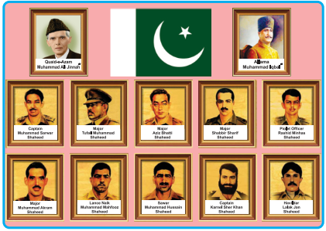
Figure 7. Examples of positive self-presentation
The assimilation and dissimilation strategies are used to refer to foreign rule, establishment of English rule over the Indian sub-continent. The different groups living in South Asia came together to fight the foreign rule (references in the 1857 war between Indians and the British); Hindu Muslim unity is a widely used phrase in the early narratives of independence (references in the 1857 war between Indians and the British and working together in the early years of the Indian National Congress) though this narrative changed into two movements later, showing the use of dissimilation strategy here (reference to events leading to the All India Muslim League and the formation of the local governments by the Indian National Congress called Hindu governments). The phrases ‘two nation theory’ and ‘Hindu and Muslim are two different nations’ are used in the independence narrative found in all the textbooks. The textbooks also have words ‘locals, foreigners, superior and subordinates’ which show the use of the dissimilation strategy. The narratives depict British and Hindus coming together to harm the interests of Muslims in the Indian sub-continent. The words repression, subjugation, poverty, slavery, resistance and freedom are found in all textbooks.
The local culture was transformed because of Muslim influence and the Muslim rulers ruling the Indian sub-continent. The writers have used transformation and homogenization strategies to communicate these messages. The Muslim rulers are presented positively and their advent and their civilization has transformed the Indian society and this is presented visually as well. The buildings and infrastructure constructed by different Muslim rulers (such as Taj Mahal and Grand Trunk Road) is presented as a great contribution in the development of the India subcontinent. The Indian society is presented as evolving and values of equality and justice prevailing under Muslim influence. The British rule is presented as an effort to de-Islamise government structure and society. The textbooks present the English rule as anti-Muslim and anti-Islam. The government and other structural changes introduced by British rule are called anti-Muslim agenda. The war of 1857 is presented as a struggle of Indians against the British rule. This event is also presented as a turning point in Muslim identity as British rulers blamed Muslims for this war of independence.

Conclusion
This study has tried to understand the social studies textbooks using four elements (see Table 1) and found evidence of biasness in the selection and presentation of history, especially by ignoring and backgrounding the historical events and achievements (social, cultural, political, scientific) that happened between 232BC and 712AD, a gap of almost 900 years between them. The textbooks writers need to inform readers (students and teachers) about these 900 years and help them learn and appreciate the achievements of local rulers, politicians, and scientist along with the Muslim (from Arabian peninsula and areas now part of Afghanistan, Iraq and Iran) rulers and scientist and explorers. The textbooks should also need to give some space to social heroes, irrespective of their religious beliefs.

References
Anderson, B. (2006). Imagined Communities: Reflections on the origin and spread of nationalism. New York: Verso.
Ayaz Naseem, M., & Stöber, G. (2014). Textbooks, identity politics, and lines of conflict in South Asia. Journal of Educational Media, Memory, and Society, 6(2), 1–9.
Aziz, K. K. (1993a). Historians of Pakistan. Lahore, Pakistan: Vanguard Books.
Aziz, K. K. (1993b). Murder of history in Pakistan. Lahore, Pakistan: Vanguard Books.
Aziz, K. K. (1993c). The murder of history: A critique of history textbooks used in Pakistan. Lahore, Pakistan: Vanguard Books.
Benwell, B., & Stokoe, E. (2006). Discourse and identity. Edinburgh, UK.: Edinburgh University Press.
Bhabha, H. K. (Ed.). (1990). Nation and narration. New York: Routledge.
Billig, M. (1995). Banal Nationalism. London, U.K.: SAGE Publications, Inc.
Bourdieu, P., & Passeron, J.-C. (1977). Reproduction in education, society and culture. London: SAGE.
Bourdieu, P., Wacquant, L. J. D., & Farage, S. (1994). Rethinking the state: Genesis and structure of the bureaucratic field. Sociological Theory, 12(1), 1–18.
Broadfoot, P. (2000). Comparative education for the 21st century: Retrospect and prospect. Comparative Education, 36(3), 357–371.
Calhoun, C. (1993). Nationalism and ethnicity. Annual Review of Sociology, 19, 211–239.
Calhoun, C. (1997). Nationalism. Buckingham, UK: Open University Press.
Calhoun, C. (2007). Nationalism and cultures of democracy. Public Culture, 19(1), 151–173. https://doi.org/10.1215/08992363-2006-028
Chughtai, M. (2015). What produces a history textbook? Harvard University.
Cowen, R. (1996). Last past the post: comparative education, modernity and perhaps post-modernity. Comparative Education, 32(2), 151–155.
Dean, B. L. (2005). Citizenship education in Pakistani schools: Problems and possibilities. International Journal of Citizenship and Teacher Education, 1(2), 35–55.
Dean, B. L. (2008). Preparing democratic citizens in Pakistani schools. Citizenship Teaching and Learning, 4(1), 65–81.
Durrani, N. (2008). Schooling the “other”: The representation of gender and national identities in Pakistani curriculum texts. Compare, 38(5), 595–610.
Durrani, N. (2013). Pakistan: Curriculum and the construction of national citizens. In M.-E.-R. Ahmed (Ed.), Education in West Central Asia (pp. 221–239). London: Bloomsbury.
Durrani, N., & Dunne, M. (2010). Curriculum and national identity: Exploring the links between religion and nation in Pakistan. Journal of Curriculum Studies, 42(2), 215–240.
Durrani, N., Halai, A., Kadiwal, L., Rajput, S. K., Novelli, M., & Sayed, Y. (2017). Education and social cohesion in Pakistan. Karachi: University of Sussex.
Eley, G., & Gellner, E. (1984). Nations and Nationalism. Contemporary Sociology, 13(6), 767. https://doi.org/10.2307/2070853
Eley, G., & Suny, R. G. (1996). Introduction: From the moment of social history to the work of cultural representation. In G. Eley & R. G. Suny (Eds.), Becoming national: A reader. Oxford, UK: Oxford University Press.
Foucault, M. (1980). Power/knowledge: Selected interviews and other writings, 1972-1977. (C. Gordon, Ed., C. Gordon, L. Marshall, J. Mepham, & K. Soper, Trans.). New York: Pantheon Books.
Gellner, E. (1983). New Perspectives on the Past. (M. R. I., G. Aylmer, I. Lewis, & P. Wormald, Eds.). Oxford, United Kingdom: Basil Blackwell Publisher Limited.
Government of Pakistan. Educational Policty 2009 (2009). https://doi.org/10.1017/ CBO9781107415324.004
Government of Pakistan. (2017). National education policy 2017-2025. Islamabad.
Gramsci, A. (2001). Further selections from the prison notebooks. (D. Boothman, Ed. & Trans.). The Electric Book Company Ltd.
Hall, S. (1992). The question of cultural identity. In S. Hall, D. Held, & A. G. McGrew (Eds.), Modernity and its future. Cambridge, UK: Polity Press.
Hall, S. (1996). Ethnicity: Identity and difference. In G. Eley & R. G. Suny (Eds.), Becoming national: A reader (pp. 339–351). Oxford, UK: Oxford University Press.
Hobsbawm, E. J. (1996). Language, culture, and national identity. Social Research, 63(4), 1065–1080.
Khan, G. (2016). Contextualizing history curriculum: A qualitative case study in Balochistan Pakistan. Univeristy of North Texas.
Klerides, E. (2010). Imagining the textbook : textbooks as discourse and genre. Journal of Educational Media, Memory & Society, 2(1), 31–54.
Lall, M. (2008). Educate to hate: The use of education in the creation of antagonistic national identities in India and Pakistan. Compare, 38(1), 103–119.
Lall, M. (2012). Citizenship in Pakistan: State, nation and contemporary faultlines. Contemporary Politics, 18(1), 71–86.
Lall, M. (2014). Engaging the youth – citizenship and political participation in Pakistan. Commonwealth and Comparative Politics, 52(4), 535–562.
Mallinson, V. (1975). An introduction to the study of comparative education. London: Heinemann.
Martin, D. (1995). The choices of identity. Social Identities, 1(1), 5–20.
Miller, D. (1995). On nationality. Oxford, UK: Clarendon Press.
Muhammad, Y. (2015). Pakistani national identity , cultural diversity , and global perspectives: A policy trajectory study of the national curriculum for secondary school Pakistan Studies in Punjab. University of Tasmania.
Naseem, M. A. (2006). The soldier and the seductress: a post‐structuralist analysis of gendered citizenship through inclusion in and exclusion from language and social studies textbooks in Pakistan. International Journal of Inclusive Education, 10(4–5), 449–467.
Nayyar, A. H., & Salim, A. (2005). The subtle subversion: The state of curricula and textbooks in Pakistan. Islamabad.
Ozkirimli, U. (2010). Theories of nationalism: A critical introduction (2nd ed.). New York: St. Martin’s Press.
Raina, A. (2014a). Democrats and minority marginalization: The case of Pakistan. Asian Journal of Political Science, 22(2), 206–226.
Raina, A. (2014b). Minorities and representation in a plural society: The case of the Christians of Pakistan. South Asia: Journal of South Asia Studies, 37(4), 684–699.
Rosser, Y. (2004). Pakistani Studies Textbooks can cause cognitive dissonance in students. Islamabad: The Sustainable Development Policy Institute (SDPI).
Rosser, Y. C. (2003). Curriculum as destiny: forging national identity in India, Pakistan, and Bangladesh. The University of Texas at Austin.
Saigol, R. (2005). Enemies within and enemies without: The besieged self in Pakistani textbooks. Futures, 37, 1005–1035.
Saigol, R. (2010). Radicalization of state and society in Pakistan. Heinrich Boll Stiftung Pakistan.
Smith, A. (1999). Myths and memories of the nation. Oxford, UK: Oxford University Press.
Smith, A. (2001). Nationalism: Theory, ideology, history. Cambridge, UK: Polity Press.
Smith, A. (2003). Nationalism and modernism: A critical survey of recent theories of nations and nationalism. Contemporary Sociology. London: Routledge.
Wodak, R. (2006a). Discourse-analytic and socio-linguistic approaches to the study of nation(alism). In The SAGE Handbook of Nations and Nationalismand nationalism. London: Sage.
Wodak, R. (2006b). History in the making/the making of history: The ‘German Wehrmacht’in collective and individual memories in Austria. Journal of Language and Politics, 5(1), 125–154.
Wodak, R. (2012). Language, power and identity. Language Teaching, 45(2), 215–233. https://doi.org/10.1017/S0261444811000048
Wodak, R., De Cillia, R., Reisigl, M., & Liebhart, K. (2009). The discursive construction of national identity (2nd ed.). Edinburgh: Edinburgh University Press.

Assistant Professor, Forman Christian College (A Chartered University), Faculty of Education, Ferozpur Road, Lahore-54600. Email: asharkhokhar@fccollege.edu.pk

